Phillip Wallace Berthelot
June 14, 1896 – July 5, 1955

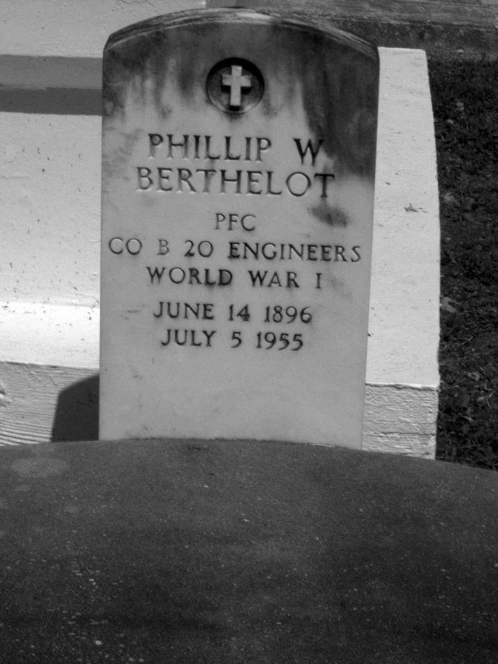
Photo by Mary Agnes Hammett

BERTHELOT – At Veterans hospital, Gulfport, Miss., on Tuesday, July 5, 1955, at 8:15 o’clock p.m. Philip Wallace Berthelot; brother of Fortune Berthelot, Mrs. Carville Pertuis and the late Adam, Libeau, Leopold and Raoul Berthelot, Mrs. William Chapman, Mrs. Charles Brignac, Mrs. Dominic Vicknair; aged 62 years.
Relatives and friends of the family are invited to attend the funeral which will take place from the Alexander Funeral Home, Lutcher, La., on Friday, July 8, 1955, at 4 o’clock p.m. followed by religious services at St. Joseph’s church, Paulina, La.
Interment in St. Joseph’s cemetery, Paulina, La.
Unknown newspaper clipping

