Raoul Joseph Berthelot Sr.
March 12, 1912 – August 10, 1983

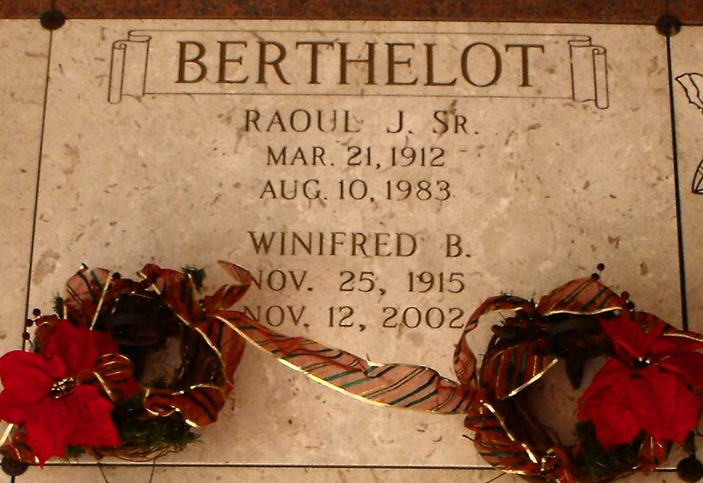
Photo by Mary Agnes Hammett

BERTHELOT SR., RAOUL JOSEPH

Died Wednesday, Aug. 10, 1983, at East Jefferson Hospital, Metairie. He was 71, a resident of Kenner for seven years and a native of Paulina. Visiting at Alexander Funeral Home, 107 Jefferson Highway, Lutcher, 8 a.m. to 12:45 p.m. Friday. Religious services at Sacred Heart Catholic Church, Gramercy, at 1 p.m. Friday. Entombment in St. Joseph Mausoleum, Paulina. Survived by his wife, Winnie Bourgeois Berthelot, Kenner; four daughters, Mrs. John E. (Arleen) Brignac Jr., Baton Rouge, Mrs. Noel M. (Winnie) Gilbert, River Ridge, and Mrs. Coleman H. (Theresa) Oubre, Norco; a son, Raoul J. Berthelot Jr., Kenner; two sisters, Antoinette Perret and Gertrude Bossier, both of Gramercy; two brothers, Joseph and Pershing Berthelot Sr., both of Gramercy; 10 grandchildren. Preceded in death by his parents, Lebeau and Elisca S. Berthelot; and a brother, Antoine Berthelot.

Morning Advocate, Baton Rouge, Louisiana
Friday, August 12, 1983, p. 12-C

