Theresa (Millet) Berthelot
March 5, 1928 – November 5, 2004

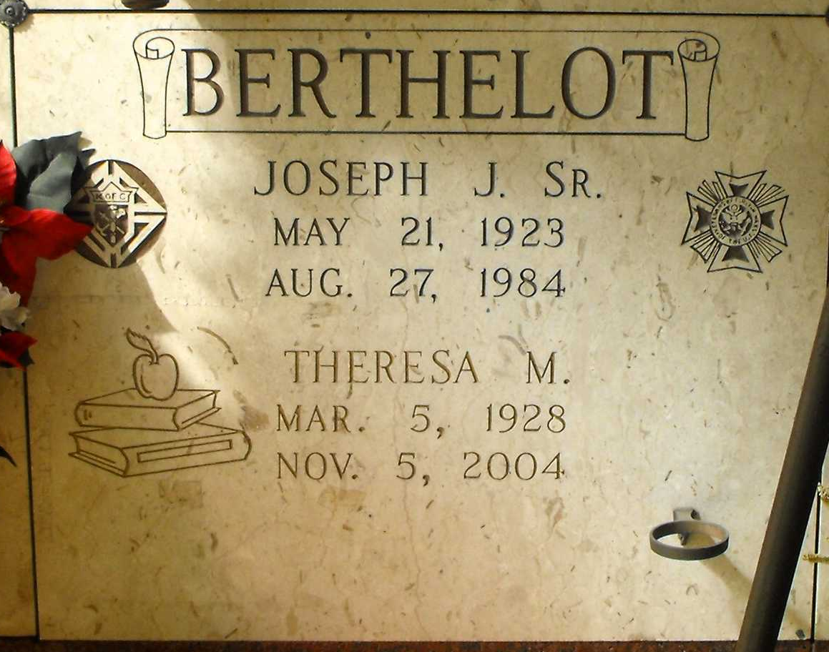
Photo by Mary Agnes Hammett

Theresa Millet Berthelot, age 76, died Friday, November 5, 2004 at Our Lady of the Lake Hospital. She was preceded in death by her husband, Joseph Berthelot, Sr., her parents, Sidney and Adele Millet, brother and sister, Sidney Millet, Jr. and Lucille "Lucy" Millet. She is survived by sons: Joseph Berthelot, Jr. and Sidney Berthelot both of Grand Point. Daughters: Adele Berthelot, Elisca Delatte and Theresa "Tess" Berthelot all of Gramercy. Brothers: Jerome "Jerry" Millet of Salem, NH, and Godfrey Millet of Gramercy. Grandchildren: Devin, Kenny, Dustin, Joshua and Hannah Berthelot and Lucy and Michael Delatte. Mrs. Berthelot was a beloved mother, grandmother and teacher of St. James and St. John Parishes.
Mass of Christian Burial will be 2:30pm on Monday, November 8, 2004 at Sacred Heart Catholic Church in Gramercy with Father Frank Uter, officiating. Visitation will be Sunday, November 7, 2004 from 6:00pm until 9:00pm and Monday, November 8, 2004 from 9:00am until 2:00pm at the H. C. Alexander Funeral Home of Lutcher. Entombment in St. Joseph Mausoleum in Paulina. H.C. Alexander Funeral Home of Lutcher, in charge of arrangement

Times-Picayune, The (New Orleans, LA)
November 7, 2004, p. 4

