Violet Ann (Duhon) Berthelot
August 31, 1931 – March 13, 2005

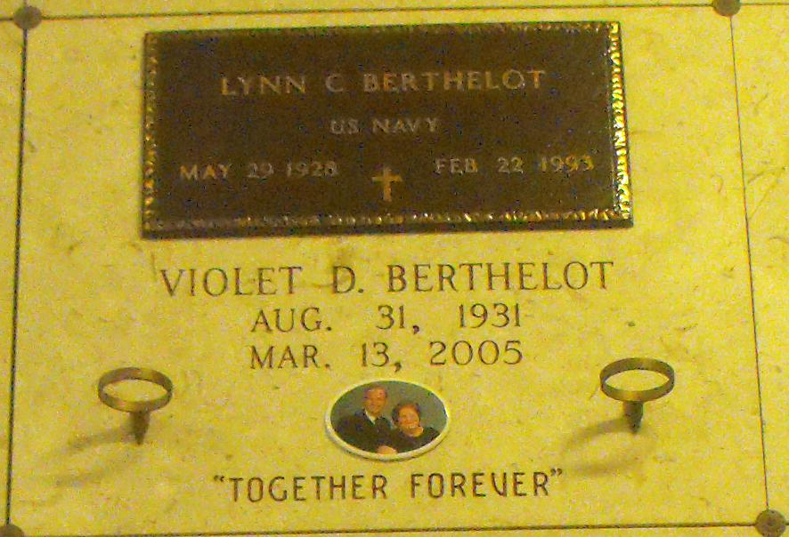
Photo by Mary Agnes Hammett

Violet Ann Berthelot, Age 73, Died Sunday, March 13, 2005 At Kenner Regional Hospital.
She Was Preceded In Death By Husband Lynn Berthelot. Parents Eddie And Viola Duhon. Daughter Cara Villeret, Son Darren Berthelot And Grandson Brenton Clouatre.
She Is Survived By Son And Daughter- In-Law Kevin And Sharon Of Gonzales. Daughters And Son-In-Law Laura And Elton Clouatre Jr. Of Gramercy And Nanette Berthelot And Marvin Roussel Of Gramercy. Son-In-Law Timmy Villeret Of Reserve. Brothers Ned Duhon Of Laplace And Eddie Duhon Jr. Of Baton Rouge. Sisters Audrey Cambre Of Reserve, Mary Michel Of St. Amant, Alice Zeringue Of Destrehan And Glenda Vedros Of Laplace, 5 Grandchildren Nicole And Derek Berthelot, Chase And Marcy Villeret And Brandy Clouatre And 2 Great-Grandchildren De 'Andre Joseph And Jaxon Berthelot.
Visitation Will Be 6:00 Pm Until 10:00 Pm Tuesday, March 15, 2005 And Wednesday 8:00 Am Until 9:30 Am At The H.C. Alexander Funeral Home In Lutcher. Mass Of Christian Burial Will Be Wednesday, March 16, 2005 At 10:00 Am At Sacred Heart Catholic Church In Gramercy . Entombment St. Joseph Mausoleum In Paulina.
H.C. Alexander Funeral Home Of Lutcher In Charge Of Arrangements.
The Times Picayune, New Orleans, Louisiana
March 15, 2005

