Winifred (Bourgeois) Berthelot
November 25, 1915 – November 12, 2002

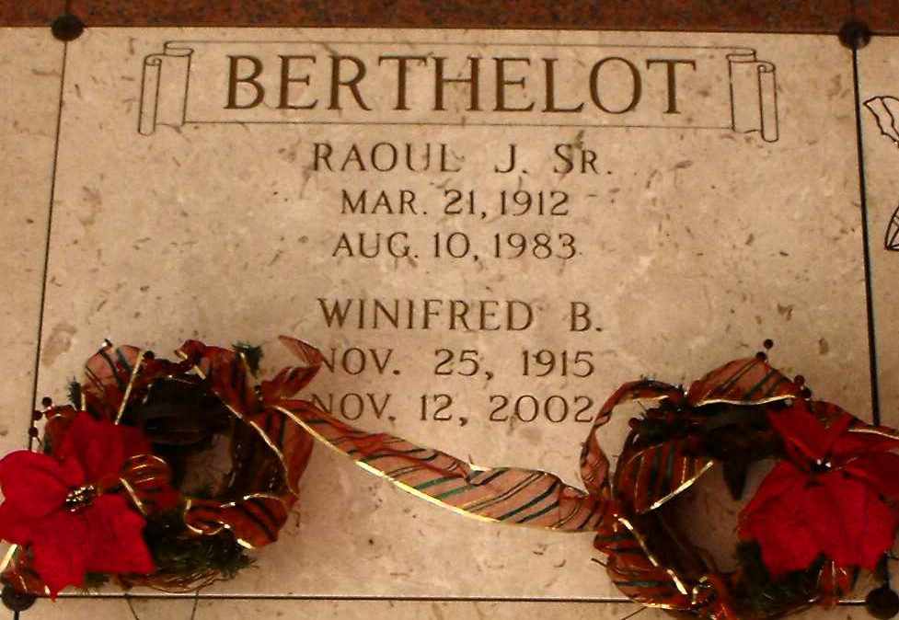
Photo by Mary Agnes Hammett

Winifred Bourgeois Berthelot passed away at her residence on Tuesday, November 12, 2002. A native of Gramercy, LA, she lived in the Kenner area for 8 years and for the last 17 years she resided in Baton Rouge, LA. Age 86 years. Mrs. Berthelot was a homemaker.
Wife of the late Raoul Berthelot, Sr. Daughter of the late James and Dora Bourgeois. Mother of Raoul J Berthelot, Jr, Arleen Brignac and husband J E Brignac, Jr, Winifred Gilbert and husband Noel, Theresa Oubre, Melinda Becnel and the late Donald Becnel. Sister of the late Marie Bourgeois Tircuit, Oliver, Garland and Margie Bourgeois. Half-sister of Elthridge Boucvault, Thisby Cook and Earlina Knight. She is also survived by 10 grandchildren and 8 great grandchildren.
Family and friends are invited to attend funeral services. A Mass of Christian Burial will be celebrated at 11:00 a.m. on Friday, November 15, 2002 at Sacred Heart of Jesus Catholic Church in Gramercy. Interment to follow at St. Joseph's Mausoleum, Paulina, LA. Arrangements under the direction of H.C. ALEXANDER FUNERAL HOME, 2208 Jefferson Hwy, Lutcher, LA.
The Times-Picayune, New Orleans, Louisiana
November 14, 2002

