Janice Cecilla Mae Bevil
December 30, 1969 - August 23, 2025

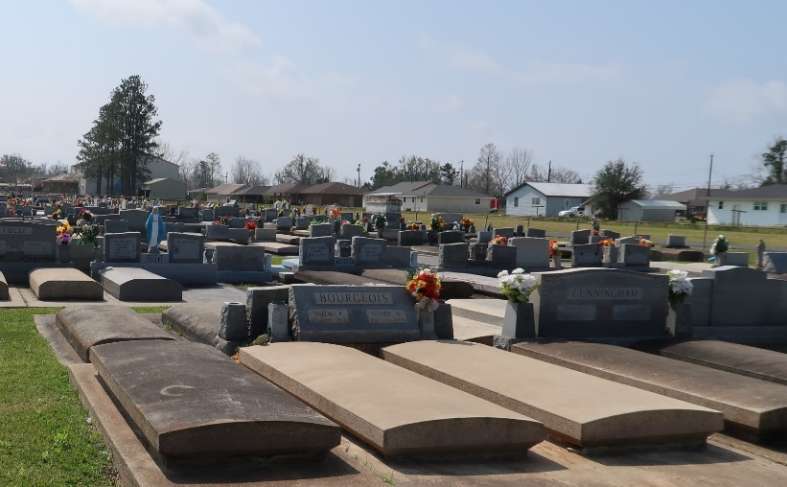

Janice C. Bevil, a native of Gramercy, Louisiana, passed away peacefully at her home on August 23, 2025, at the age of 55.
She is survived by her loving children, Skyler Deroche Robert (Tycer), Chance Hebert; her grandchildren, Sarah and Dalton Pearce; and her brother, Johnny M. Bevil. Jan also leaves behind special family friends Karen, Paul, and Chad Remondet, who held a dear place in her heart.
She was preceded in death by her parents, John and Sharon Bevil; her brothers, Scott Traylor and Barry Bevil; and her beloved boyfriend, Alan Porche Sr. (Tattoo)
Jan will be remembered for her strength, sense of humor, smile, vivacious personality, the way she listened to you & gave the best advice.
Visitation will be held on Friday, August 29, 2025, from 1:00 p.m. until 3:00 p.m. at Roselyn Funeral Home, 1870 Cabanose Ave., Lutcher, La 70071. Interment will take place at St. Joseph Cemetery a later date. Family and friends are invited to gather following the services at Karen and Paul’s residence, 39277 Carly Lane, Paulina, Louisiana 70763.
The family would like to thank everyone who extended their love and support during this difficult time.

Rose Lynn Funeral Home, Lutcher, Louisiana
August 27, 2025

