Roy Blank, Sr.
September 14, 1930 - September 27, 2025

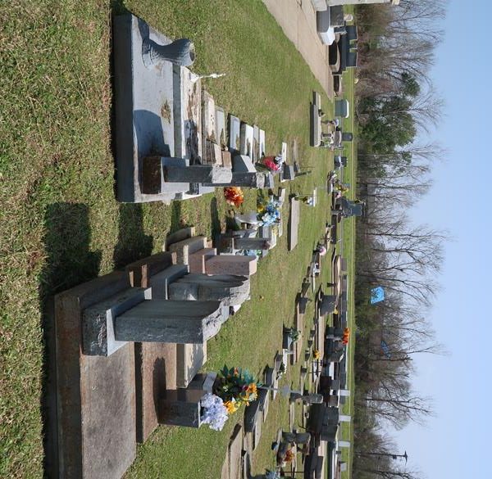

Roy “Cokey” Blank, Sr. entered eternal rest on Saturday, September 27, 2025, at the age of 95, with his loving children, Becky, Cindy, and Roy, Jr by his side.
Born in Lutcher on September 14, 1930, he resided in Gramercy, Louisiana. Father to Roy Blank, Jr. (Allison), Cindy Blank, Becky Veron (Greg), Darlyn Laiche (Nicholas), and Karen Bond (Jeff). He is survived by 8 grandchildren, several great grandchildren, and nieces and nephews.
Preceded in death by his loving wife, Winnie Moran Blank; parents, Florence and Humphrey Blank; sisters, Rita, Evelyn, Lucille, Ruth, Joyce, Judy, and Kathleen; and brothers Roy, Ray, Percy, Glenn, and Herman.
Cokey proudly served as a medic with the 28th General Hospital in the United States Army during the Korean War. He achieved the ranking of Corporal. He was also a V.F.W. member. He was employed at Colonial Sugars for over 50 years, serving as a laborer, yard-gang foreman, and contract supervisor.
He loved country music, especially Hank Williams, Sr. His hobbies included trawling for shrimp in Dulac, raising catfish cans in Lake Des Allemands, and building camps on Blind River, Dulac, and Belle River. Cokey enjoyed hunting rabbits with his favorite dog, Gal, crawfishing with deep pocket nets the old fashioned way, and catching redfish in Dulac with a gold spoon. He also really liked playing the slot machines at the casinos and watching LSU sports. Overall, he treasured spending time with his family.
Relatives and friends are invited to attend a Funeral Mass and Visitation at Sacred Heart of Jesus Church, 616 E. Main St. Gramercy, LA 70052, on October 2, 2025. Visitation will be held at the church from 9:00 a.m. to 11:00 a.m. A Funeral Mass will follow at 11:00 a.m. Interment will take place after services at St. Joseph Cemetery, Paulina, LA.

Rose Lynn Funeral Home, Lutcher, Louisiana
September 30, 2025

