Gwynne (DeRoche) Bordelon
January 26, 1940 – July 13, 2025

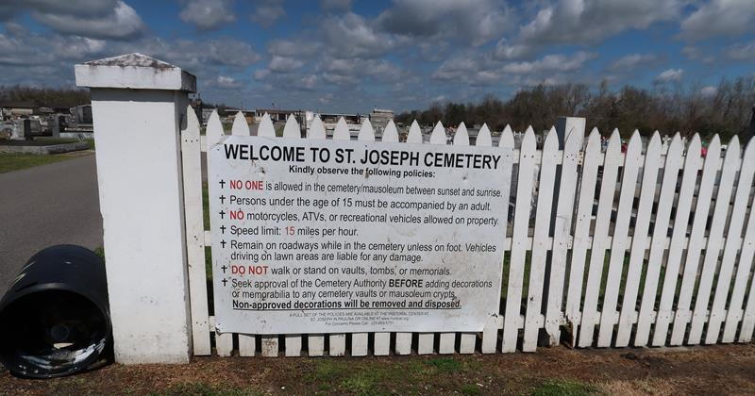

Gwynne “Feenie” DeRoche Bordelon, a native and resident of Lutcher, passed away peacefully on July 13, 2025, at the age of 85. She was born on January 26, 1940, to her parents Sheffard “Shep” and Marie Whitney Deroche. She was preceded in death by her parents, her sister Stephanie Deroche Kim, her husband Louis Bordelon, and her son Stanley Pollet.
Gwynne was the mother of Louis Savoie, Lloyd “Poochie” Pollet (Jeani), Lori Taylor (Brian), Nikki Eymard (Gary), and Erica Bordelon (Damien). She was a devoted grandmother to many grand and great-grandchildren whom she loved unconditionally.
She is survived by her two brothers, Sheffard “Butch” Deroche (Gayle) and Louis Deroche (Kelly). Gwynne will be greatly missed by numerous friends, cousins, nieces, nephews, and godchildren.
Fondly known as Feenie to many and Mamie to her family, she was a devout Catholic who loved Jesus and enjoyed singing and humming along to church hymns. Her perseverance in the faith brought her joy and also strength in the face of adversity throughout her life. She became known for her friendly smile as she served the community for years working at local pharmacies. She enjoyed laughing, was always humming, and most of all being with her family. Over the years she could be found watching her soap operas, game shows, murder mysteries, and Saints football games. Feenie will be deeply missed and always cherished by so many.
The family would like to thank Chateau St. James for the many years of care given to Gwynne, as well as Thibodaux Regional Hospital and St. Joseph Hospice. Relatives and friends are invited to attend the Funeral Service at St. Joseph Catholic Church in Paulina on Saturday, July 19, 2025. Visitation will be held in church from 9:00 a.m. to 11:00 a.m. with the Funeral Mass at 11:00 a.m. Interment to follow in St. Joseph cemetery.

Rose Lynn Funeral Home, Lutcher, Louisiana
July 14, 2025

