Barbara Ann (Cambre) Bourgeois
September 24, 1939 - April 17, 2025

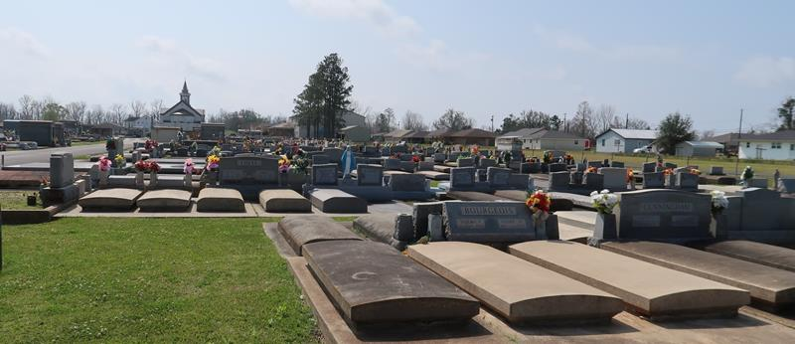

Barbara Cambre Bourgeois entered eternal rest on Wednesday, April 16, 2025, at St. James Parish Hospital surrounded by family and friends. Mother of Karen B. Nichols and Ray J. and Vicki Bourgeois, Jr. Grandmother of Larry “Boe” and Erica Nichols (Dalton and Taylor Nichols, Keeley Cormier, Brianna Galley), Michael and Christina Nichols (Preston, Christian, and Cadence Nichols), Shane and Stephanie Nichols (Hayden, Allie, and Ryleigh), Shawn and Courtney Nichols (Colson and Kellen), Kylah Nichols (Michael Kahl III and Gage Brammer), Tyler J. Bourgeois, Blake and Dees Rome (Emmie and Kinsey), and Brooke and Paul Faucheux (Bentley and Breigh). Great-great-grandmother of 5. Sister of Linda Lamondo.
Barbara was preceded in death by her husband, Ray J. Bourgeois, Sr., daughter, Cheryl Ann Bourgeois, parents, Louis and Vivian Cambre, siblings Harris “Buddy” Cambre, Brenda Hales, and Margaret Deroche, and in-laws, Wilfred and Blanche Bourgeois.
Barbara lived a life of service to others. She was a seamstress for family, friends, and strangers. From working on simple hems to creating elaborate costumes, Barbara was sought after to create works of beauty with her sewing machine and thread. She never turned away any sewing jobs. The only thing Barbara did better than sewing was helping family and friends file out their income taxes. She may not have been a certified tax preparer, but Barbara could help people get their largest tax return. And finally, in later years of her husband’s life, Barbara turned her talents to working in the cafeteria at Gramercy Elementary School. This chapter of Barbara’s life was never overshadowed by her love of sewing and tax preparation. Barbara will be missed by her loving family and friends as she now rejoices with her loved ones in God’s Heavenly paradise.
Relatives and friends are invited to attend a celebration of Barbara’s life on Thursday, April 24, 2025 with a visitation from 9 a.m. until 12:00 p.m. followed by a Mass of Christian Burial at 12:00 p.m. at Most Sacred Heart of Jesus Catholic Church, Gramercy, LA. Entombment at St. Joseph’s Cemetery, Paulina, LA.

Rose Lynn Funeral Home, Lutcher, Louisiana
April 19, 2025

