Joyce (Tamplain) Bourgeois
March 3, 1930 – September 16, 2021

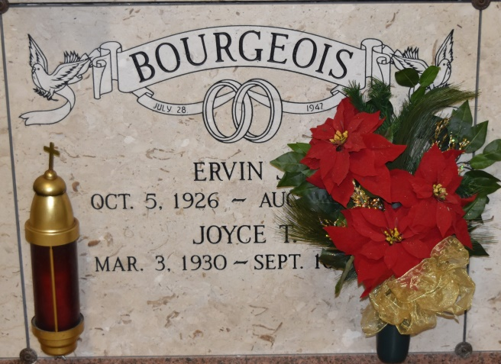
Joyce was born on March 3, 1930 and passed away peacefully at home on September 16, 2021 at the age of 91 years old. She was a native of Garyville, LA and resident of Gramercy, LA.
Joyce was a devoted wife, mother, and grandmother. She loved nothing more than being a housewife and spending time with her children, grandchildren, and her beloved dog, Lady. One of her favorite places to visit was the St. Michael’s Catholic Church Grotto. She would visit weekly to pray and light candles. She also enjoyed spending time with friends and family on the weekend. Many Sundays were spent dancing, eating, and shopping.
Joyce is survived by her children, Greg Bourgeois (Wanda), Gary Bourgeois, and Keith Bourgeois; grandchildren, Heather Abadie (Byron), Denny Bourgeois, Emily Lambert (Brian), and Katie Alexander (Dana); great-grandchildren, Sarah Peeler, Lea Lambert, Landon Lambert, Maddison Simpson, Paisley Alexander, Ava Alexander, Nathan Abadie, and Nicholas Abadie; and beloved dog, Lady.
She is preceded in death by her husband, Ervin “Buddy” Bourgeois; parents, Lewis and Josephine Tamplain; and siblings, Lewis Tamplain, Jr., Harry Tamplain, Daniel Tamplain, E.J. Tamplain, Delia Vicknair, Esther Waguespack, and Nettie Atkins.
A visitation will be held at Sacred Heart Catholic Church in Gramercy, LA on Monday, September 20, 2021 from 9:00 AM to 11:00 AM followed by a Mass of Christian Burial. Interment will take place in the St. Joseph Catholic Church Cemetery in Paulina, LA.

Rose Lynn Funeral Home, Lutcher, Louisiana

