Kim James Bourgeois
October 28, 1957 - July 5, 2025

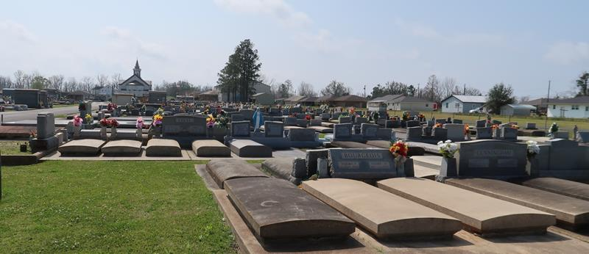

Kim Bourgeois, a resident of Paulina, passed away on Saturday, July 5, 2025, at the age of 67.
Kim grew up in Paulina. He loved hunting, fishing, when he was able, but especially loved watching his grandkids compete in sports. He was a jack of all trades. Always fixing things. Kim was a devoted Catholic and very generous and helpful to anyone who needed it. He also served his country in the Air Force.
Survived by son Christopher Bourgeois (Brandi), grandchildren, Kole Bourgeois & Kori Bourgeois. Brothers and sisters; Wendell ‘Duke’ Bourgeois (Connie), Hope Zeringue (Sonny), Dawn Fortenberry (Daryl), Timothy ‘Droopy’ Bourgeois (Susan), Mickey ‘Mice’ Bourgeois (Harriet), Todd ‘Scrap’ Bourgeois (Melissa), Sherry Martin (Danny), Mary St. Pierre (Jude), Miles ‘Frog’ Bourgeois (Ashley), Steven Bourgeois (Cindy).
Preceded in death by his wife Annette Perilloux Bourgeois, son Jessie Bourgeois, parents Charles Lindy & Nellie Roussel Bourgeois; In-laws Emile and Linda Perilloux, sister in law Donna Perilloux Leblanc and brother in law Curtis Perilloux.
Relatives and friends are invited to attend the Visitation and Funeral Services on Friday July 11th, 2025 from 9:00 am-11:00 am with Mass to start at 11:00 am at St. Joseph’s Catholic Church, 2130 Rectory St, Paulina, LA 70763. Burial in St. Joseph Catholic Cemetery immediately following the services.

Rose Lynn Funeral Home, Lutcher, Louisiana
July 9, 2025

