Marie Theresa (Hymel) Bourgeois
November 30, 1929 – September 2, 2012

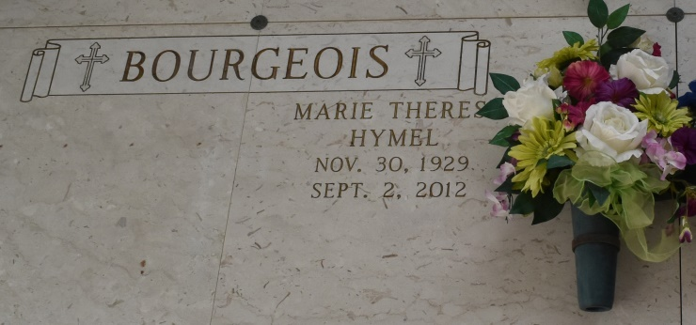

Marie "Bouke" H. Bourgeois, a native of Mt. Airy and a resident of Gramercy, died on Saturday, September 2, 2012 at 8:20 p.m. Visitation will be on Wednesday, September 5, 2012 from 2:00 PM till 3:15 PM. at Sacred Heart in Gramercy, LA. A Mass of Christian Burial will take place at 3:30 P.M. at the church with burial in St. Joseph Cemetery in Paulina, LA. She was 82 years old and is survived by her beloved devoted husband of 62 years Alton "Cook" J. Bourgeois Sr., and 2 daughters and their husbands, Fae B. Oubre (Danny), Nanette B. Lackie Carter (Jerry); 2 sons and their wives, Alton "Toon" J. Bourgeois Jr. and Allison and Marcel H. Bourgeois and Kim. She also had 12 grandchildren and 11 great grandchildren; a sister, Florence H. Bourgeois and husband Gaston. Preceded in death by her mother and father, Sevien and Edna Hymel; sisters, Marie H. Zeringue and Thelma H. Roussel; son-in-law, Joseph "Jay" Lackie; a grandson, J. Eythan Lackie. She has been a loving and caring, devoted wife, mother and grandmother to all and always there to help. She was admired by many and will forever be in our hearts. She was a Eucharistic minister, sacristan of Sacred Heart Church for 30 years. She was also an adorned member of the Lutcher Adoration Chapel for Sacred Heart Church. Arrangements under the direction of ROSE LYNN FUNERAL SERVICES, 1870 Cabanose Ave., Lutcher, LA. To sign and view the family guestbook, please visit www.roselynnfuneralhome.com.
Published in The Advocate (Baton Rouge, LA) from September 3 to September 4, 2012

