Hubert Joseph Brignac
Abt. 1934 – May 20, 2025

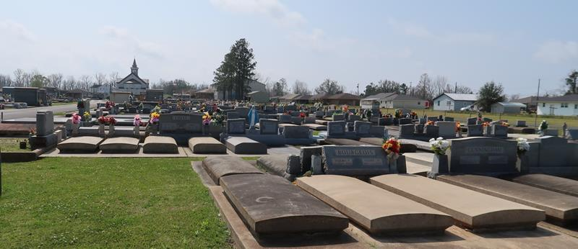

Hubert Joseph Brignac, a native of Gramercy and resident of Lutcher, Louisiana, passed away on May 20, 2025, at the age of 91.
At 19, Hubert proudly served as a U.S. Army Paratrooper and later in the Army Reserves, achieving the rank of Sergeant. He built a career as a skilled mechanic at Kaiser Aluminum, earning the nicknames “The Lil General” and “Sarge”. He also had the ability to fix anything and everything. He cherished time with family and friends, especially at the LPG Hunting Club along Blind River.
He is lovingly remembered by his devoted wife of 68 years, Margie Michel Brignac, who affectionately called him “Baby”; his children Angela B. (Ross) Duhe, Carl (Doris P.) Brignac, Cheri B. Farmer, Todd (Lauren S.) Brignac, and Chantel B. (Angel) Soriano; his grandchildren Jenna Sauber, Seth (Jennie) Brignac, Taylor (Shayla) Brignac, Collin (Alex) Farmer, Jourdan (Katie) Farmer, Quentin Duhe, Alexander, Jonathan, and Andre Soriano; and his great-grandchildren Grayson and Blaine Farmer, along with Emily and Olivia Brignac. He is also survived by his siblings Joyce Ann B. (Gary) Cazenave and Melvin (Cynthia) Brignac, as well as his sisters-in-law Joyce Brignac, Betty Amato, and Judy Michel.
Hubert was preceded in death by his parents, Norman Sr. and Beatrice Hymel Brignac; his in-laws Noemie Michel (Lester) and Wallace Gauthe; his son Darryl J. Brignac; his granddaughter Raini N. Scioneaux; and his siblings Mildred B. (Onezime) Lear, Norman Brignac Jr., Norris (Ruth) Brignac, Carolyn B. (Allen) Grob, along with his brothers-in-law Valfred Amato and Earl Michel.
Visitation will be held at St. Joseph Catholic Church in Paulina, Louisiana, on Saturday, May 24, 2025, from 8:30 AM until the Mass of Christian Burial at 11:00 AM, followed by entombment in St. Joseph Mausoleum with full military honors.

Rose Lynn Funeral Home, Lutcher, Louisiana
May 23, 2025

