Kathleen (Samrow) Deroche
September 29, 1952 – June 11, 2025

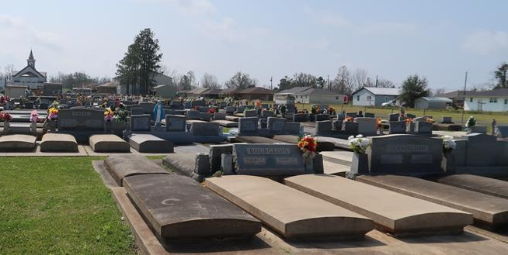

Kathleen “Kathy” Samrow Deroche, born September 29, 1952, passed away peacefully at the age of 72 in Baton Rouge, Louisiana, on June 11, 2025.
Kathy was a schoolteacher for 33 years and taught at Lutcher Elementary, Gramercy Elementary, Romeville Elementary, St. James High School, and Lutcher High School. In her years of teaching, she received many awards, grants, promotions, and achievements. Her selfless devotion to teaching led her to support her students by buying art supplies and school materials for those who struggled to afford them. She wanted each of her students to shine and be pushed to their greatest potential. She was an officer for the Gulf State Quilting Association and Quilting Fans in LaPlace. She was a member of the Delta Kappa Gamma teaching society and Catholic Daughters. As an avid reader, she loved to participate in book clubs. She was known and loved by many in the St. James Parish community. She managed and taught at River Camp for 7 years. Kathy enjoyed quilting, painting, sewing, crafting, and spending time with her 13 grandchildren. She traveled around the country to attend numerous tournaments, meets, concerts, games, performances, shows, and graduations to support her grandchildren.
Kathy is survived by Nolan Deroche Jr., her husband of 54 years; her sons Christopher Deroche (Callen) and Matthew Deroche (Haley); daughters Juanita McDonald (Webb) and Sarah Roberts (Shawn); her sister Marie Fuselier (Bobby); her brothers George Samrow and Greg Samrow (Puddin’); her sisters-in-law Karen Remondet (Paul) and Deanie Samrow; her grandchildren, Skye (Tycer), Dakota, Emily, Andrew, Erica, Hunter, Beau, Rogan, Alexa, Sawyer, Emma, and Shawn, and great-grandson Barrett. She is preceded in death by her parents, Joseph and Thekla Samrow; brother, Joseph Samrow Jr.; sister-in-law, Barbara Samrow; mother-in-law, Olive Deroche; father-in-law, Nolan Deroche Sr.; and grandchildren Baby Deroche and Baby Dahlke.
Visitation will be at Rose Lynn Funeral Home, 1870 Cabanose Ave., Lutcher, LA on Monday, June 16, 2025 from 6:00 PM until 9:00 PM and resume on Tuesday, June 17, 2025 from 9:00 AM to 11:00 AM at St. Joseph Catholic Church, 2130 Rectory St. Paulina, LA 70763. Eulogy will be led by son Chris Deroche at 10:45 AM, followed by a Mass of Christian Burial officiated by Rev. Fr. Vincent Dufresne at 11:00 AM.

Rose Lynn Funeral Home, Lutcher, Louisiana
June 13, 2025

