Marie (Whitney) DeRoche

March 23, 1919 – May 21, 2007

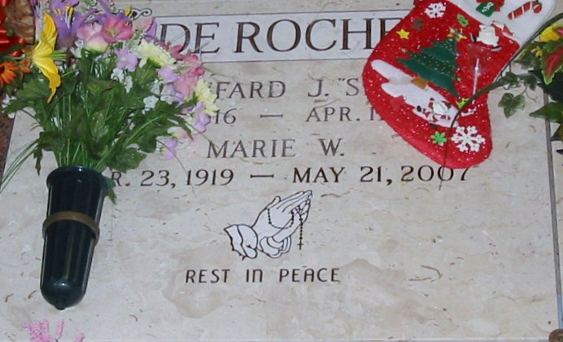

Photo by Bobby

Marie W. DeRoche, a loving wife, mother, grandmother and great-grandmother, died on Monday, May 21, 2007. She was 88 and a resident and native of Lutcher.  
 She was preceded in death by her husband, Sheffard J. DeRoche, Sr.; parents, Gilbert E. and Beatrice Lirette Whitney; four brothers, Baby Bernard, Gilbert Jr., Cornelius "Buddy" Sr. and Randolph "Tater"; two sisters, Mary W. Raymond and Carol W. Crawford; and granddaughter, Keni Deslattes.  
 Survived by four loving and devoted children, Gwynne "Feenie" Bordelon, Sheffard "Butch" Jr. and wife Gayle, Louis and wife Kelly, and Stephanie "Stevie" Kim, all of Lutcher and Gramercy; a host of grandchildren, great-grandchildren, nieces, nephews, numerous other relatives and friends. She is also survived by siblings, Timothy Whitney, Judith W. Cronin, Joan W. Gonzalez and Wayne Whitney.  
 Visitation at Rose Lynn Funeral Services, Lutcher. Mass of Christian Burial at Sacred Heart Catholic Church, Gramercy, with the Rev. Ed Fuss, celebrant. Burial in St. Joseph Cemetery, Paulina.  
  
The Advocate (Baton Rouge, Louisiana)

May 23, 2007