Clyde Gerard Dooley
April 29, 1953 - May 15, 2025

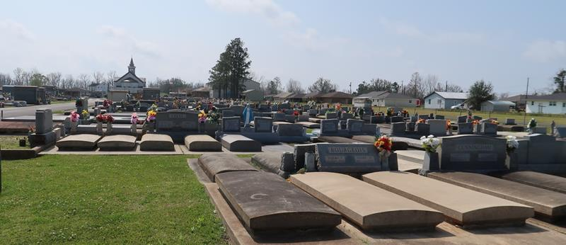

Clyde Gerard Dooley, devoted husband, father, and grandfather, passed away peacefully on May 15, 2025, at the age of 72. Clyde was born in New Iberia, LA, on April 29, 1953, and spent much of his life in Gramercy, where he was a cherished member of the community.
Clyde is survived by his beloved wife, Charlean Dooley; his children, Erin Purvis (Richard) and Tristan Dooley; stepdaughter, Vanessa Rojas (Ryan); brother, Norby Dooley Jr.; grandchildren, James and Colin Purvis and Averi, Caitlyn, and Ellie Rojas; and niece and nephew, Elizabeth and Samuel Dooley. He was preceded in death by his parents, Norby Sr. and Eva Dooley, and sister, Mary Catherine Dooley.
Clyde had an accomplished career as an engineer with GE and Mosaic before retiring. He had a love for travel—most recently enjoying a memorable trip to Disney World with his grandsons—and a passion for photography that captured the beauty he saw in the world around him. Clyde was a faithful servant of God and dedicated member of Most Sacred Heart of Jesus Catholic Church, where he served as sacristan.
Family and friends are invited to attend visitation on Thursday, May 22, 2025, from 9:00 a.m. to 11:00 a.m. at Most Sacred Heart of Jesus Catholic Church in Gramercy. A Mass of Christian Burial will follow at 11:00 a.m., with interment at St. Joseph’s Cemetery in Paulina, LA.
The family extends heartfelt gratitude to the compassionate staff at Mary Bird Perkins Cancer Center for their dedicated care.
Clyde will be deeply missed and lovingly remembered for his kind heart, generous spirit, and the unwavering love he had for his family.

Rose Lynn Funeral Home, Lutcher, Louisiana
May 18, 2025

