Mary Amanda (Daigle) Doucet
January 2, 1939 - April 11, 2026

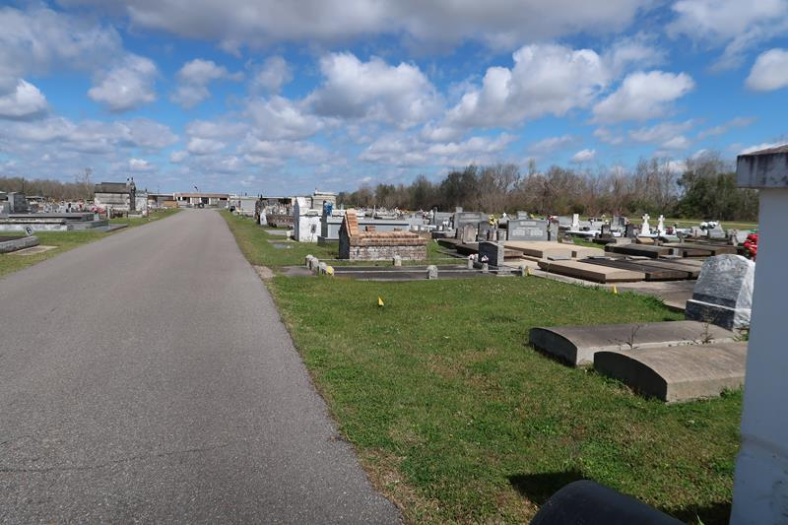

Mary Amanda Daigle Doucet a resident of Gramercy, passed away on Saturday, April 11, 2026 at the age of 87.
Wife of the late John Alvin Doucet. Loving mother of Robert Doucet (Brenda), Wendell Doucet (the late Sharon), David Doucet, Sr. (Suzanne), John Doucet (Toni), and Celeste Louque (Irvin, Sr.). Grandmother of twelve grandchildren, and twenty great-grandchildren. She is also survived by her sister-in-law, Mary Doucet. She is preceded in death by her parents Noah Daigle and Blanche LeDoux and her seven siblings.
Mary enjoyed making rosaries and ornaments, as well as sewing. Above all spending time with her family and friends. She was also a dedicated member of the Catholic Daughters, and even partook in being a lector at Sacred Heart of Jesus Catholic Church.
Relatives and friends are invited to attend the Visitation and Funeral Mass at Sacred Heart Of Jesus Catholic Church, 616 E. Main St., Gramercy, Louisiana on Thursday, April 16, 2026. A Rosary Prayer will begin at 8:30 a.m. Visitation will be held from 9:00 a.m. until 11:00 a.m., and the Funeral Mass will follow at 11:00 am. Burial will take place after at St. Joseph Catholic Cemetery, Paulina, Louisiana.
The family would like to thank St. Catherine’s Hospice and the South East War Veterans Home.

Rose Lynn Funeral Home, Lutcher, Louisiana
April 19, 2026

