Sharon (Waguespack) Doucet
February 17, 1955 - June 29, 2025

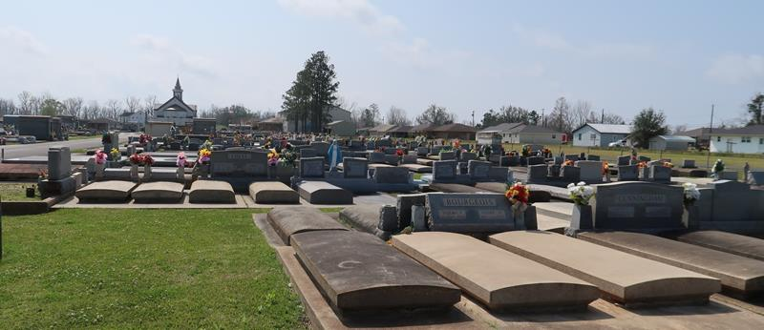

Sharon Waguespack Doucet, a resident of Paulina, LA passed away on Sunday, June 29,2025 at the age of 70.
Sharon was the second child and first girl of ten children by the late Claude J. Waguespack, Sr. and Gertrude L. Bourgeois Waguespack. She is survived by her spouse Wendell Doucet and children Neil A. Duhe, Shawn P. Duhe and Jacqueline Duhe, as well as four stepchildren. She is also survived by her siblings and their spouses Claude "C.J." Waguespack, Jr. (Sandra), Craig Waguespack (Donna), Roger Waguespack, Ricky Waguespack (the late Donna), Billy Waguespack (Jeannelle), Brian Waguespack (Cheryl), Jody Waguespack (Marsha), and Angelle Marshall (Bobby Len); aunts Mary Forsyth, Suzanne Brown; uncle Vinzule Bourgeois, Jr; mother-in-law Amanda Doucet; 17 grandchildren and step grandchildren; and many nieces, nephews, and cousins.
She is preceded in death by her brother Micky Waguespack, niece Dannille W. Smith, and godchild Dwayne Bourgeois.
Sharon was raised on property that her ancestors acquired after being part of the Acadian Expulsion. She went to St. James Parish public schools eventually graduating in 1973 from Lutcher High School Girls Division. After graduating Sharon went to Nicholas College in Thibodeaux for food science, but the call of the workforce and motherhood was too great, and she entered the workforce. She had and held multiple jobs while balancing family before landing at a St. John Parish employer and working there numerous years. After parting ways there, Sharon juggled multiple jobs as a single parent before finally landing at the Colonial Sugar Refinery where she learned numerous jobs before retiring. She loved her flowers and especially roses which gave her the incite and courage to participate in the St. James Parish Home Vegetable Garden Contest small garden division winning first place numerous times before physical challenges took their toll on her body. Sharon's love for helping others and being able to give to friends or family was truly her greatest attribute. The fighting independent and generous spirit she had, and the strength shown to others was truly amazing, sometimes at her own peril.
Relatives and friends are invited to attend the Visitation and Funeral Service on Saturday, July 5, 2025 at St. Joseph Church. Visitation from 9:00 am to 11:00 am, with the Funeral to begin at 11:00 am. Burial will immediately follow the services at St. Joseph Cemetery.

Rose Lynn Funeral Home, Lutcher, Louisiana
July 2, 2025

