Allen Carroll Duhe
October 2, 1934 - February 7, 2026

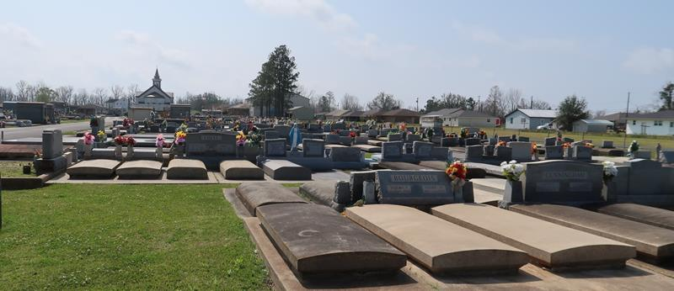

Allen C Duhe, age 91, a native of Garyville, LA and long time resident of Gramercy, LA, passed away on February 7, 2026. He is preceded in death by his beloved wife of 71 years, Jeannette Ordeneaux Duhe.
He is survived by his children and their spouses: Suzanne and Steven (Buggy) LeMoine of Paulina, LA, Cathy and Wade Gaudet of Walker, LA, and Amanda and Randy Rodrigue of Lutcher, LA. He also leaves behind four grandchildren: Steven and Jena LeMoine, Shelbi and Blair Gautreaux, Tyler Roques, and Chase and Julie Rodrigue and 3 great grandchildren: Brilynne and Colton Gautreaux and Maria Rodrigue.
He is preceded in death by his parents, John and Zeolide Deslatte Duhe and sister, Marjorie Duhe LeBouef and brother Charles Duhe. He is survived by one sister-in-law, Barbara Duhe Bueche.
Visitation will be Monday February 9, 2026 at Rose Lynn Funeral Home, 1870 Cabanose Ave., Lutcher, LA. from 9am - 10:30am. Mass will follow at St. Joseph’s Catholic Church in Paulina, LA at 11:00 a.m. Burial in St. Joseph Cemetery.

Rose Lynn Funeral Home, Lutcher, Louisiana
February 13, 2026

