Andrew Michael Duhe
January 12, 1964 - February 4, 2025

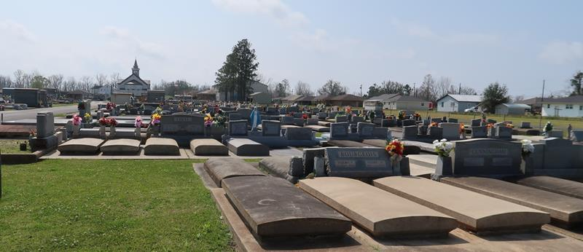

Andrew “Drew” Michael Duhe a resident of St. Amant and a native of Gramercy passed away on Tuesday February 4, 2025, at the age of 61.
Beloved husband of Paula Vicknair Duhe for 33 years. Loving father of Dillan Duhe (Janean), Brandon Duhe (Ashley), Sara Duhe (Lindon). Grandfather of Carter Duhe, Beckham Duhe , Chevy Duhe, Olivia Duhe, Ivy Duhe, LJ Williams, Laken Williams, and Marleigha Guillot. Son of the late Claude “CJ” Duhe and Violet Ordoyne Duhe. Brother of Adam Duhe, Alex Duhe (Susan), Ann Jeansonne (Glen), and Abby Guillot (Teddy). Also survived by numerous nieces, nephews, and cousins.
Drew dedicated 33 years of his life to working for St. James Parish Sheriff's Office as a Patrol Captain and filled this position up until retirement. Drew continued to serve his community as a member of the Lutcher-Gramercy Lions Club. He was known for being an avid outdoorsman. Drew enjoyed hunting, fishing, camping and gardening. He was also known for being a great cook. Drew often times cooked for major events and even competed in cook offs. He lived for his grandchildren and often took them frogging and fishing. He loved everyone, and his friends and family felt as if he never met a stranger.
Relatives and friends are invited to attend the Visitation on Monday, February 10th, 2025, at Rose Lynn Funeral Home, 1870 Cabanose Ave., Lutcher, LA from 6:00 p.m. to 9:00 p.m. Visitation will continue on Tuesday, February 11th, 2025 at St. Joseph Catholic Church, 2130 Rectory St., Paulina from 9:00 a.m. to 12:00 p.m. followed by a Funeral Mass at 12:00 p.m. Interment in St. Joseph Cemetery, Paulina, LA.

Rose Lynn Funeral Home, Lutcher, Louisiana

