Lois (Louque) Duhe
February 13, 1935 – January 3, 2026

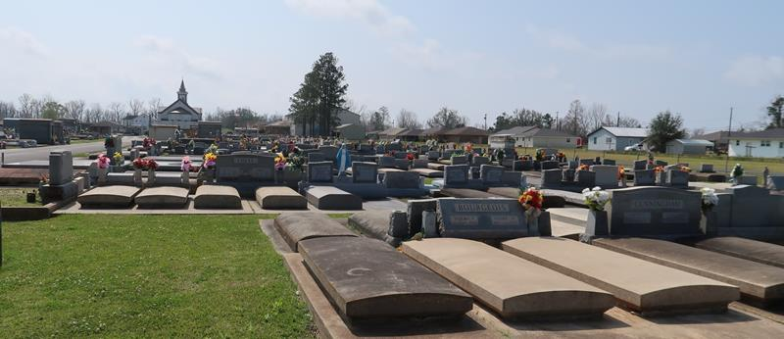

Lois Louque Duhe went home to be with the Lord on January 3, 2026, at the age of 90 years old. She was born on February 13, 1935, in Lutcher, Louisiana, and remained a lifelong resident there.
Lois was known to enjoy crocheting, playing cards with friends, gardening, and above all spending time with her family.
She was the beloved wife of Clarence Duhe and was the loving mother of William "Bill" Duhe (Wendy), Greg Duhe (Connie), Cheryl Lanier (Charles, Jr.), Glenn Duhe, Brian Duhe (June), and the late Steve Duhe. She was the grandmother of ten grandchildren, and thirteen great-grandchildren. Lois was the daughter of the late Daniel and Elise Louque. She is survived by her sister Barbara, and preceded in death by her other siblings Daniel "Neg", Gary, Kenneth, Everette, Ronald, Rita, and Jacqueline. She is also survived by many nieces and nephews.
Relatives and friends are invited to attend a visitation and funeral mass on January 8, 2026, at St. Joseph Catholic Church, located at 2130 Rectory St. Paulina, Louisiana 70763. Visitation will be held from 9:00 a.m. util 11:00 a.m. The funeral mass will begin at 11:00 a.m. Interment will follow immediately after at St. Joseph Catholic Cemetery.

Rose Lynn Funeral Home, Lutcher, Louisiana

