Patricia Ann (Chapoton) Duhe
July 18, 1941 – March 2, 2026

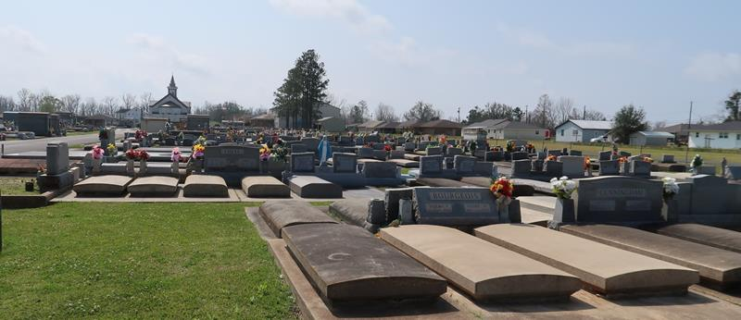

Patricia “Pat” Ann Chapoton Duhe of Lutcher, Louisiana, born on July 18, 1941, passed away peacefully on March 2, 2026, at the age of 84 at her home with her beloved husband of 66 years, Clark, at her side.
Pat was a devoted mother to Bruce (Amy), Kevin (Ronette) and Ken (Laura); the cherished daughter of the late Malcolm and Denise Brock Chapoton; and a loving sister to Conrad (Cindy) and the late Malcolm Chapoton Jr. (Marjorie).
She was blessed with eight grandchildren — Abby Altazan (Clayton), Samantha Salisbury (Daniel), Taylor (Zach Honey), Sloane (Hank Vockroth), Remi (Pete Hintze), Grace Eley (Garrett), Adam and Emma — and great-grandchildren Leo and baby girl Altazan; Scotty, Walker and baby Salisbury; Bridger and Roan Honey; and Elliot and Logan Vockroth — each of whom she showered with endless love and affection.
A Reserve, Louisiana, native and graduate of Leon Godchaux High School, Pat later earned her degree, with honors, in elementary education from Nicholls State University, also earning induction into the Phi Kappa Phi Honor Society. While married and raising three boys, she commuted to classes and devoted countless late-night hours to her studies.
She dedicated 30 years to teaching at St. Peter Chanel Interparochial School in Paulina, Louisiana, where she instilled in her students not only a love of learning, but also confidence, discipline, and a belief in their potential. The countless children whose lives she touched stand as part of her enduring legacy. In retirement, she and Clark embarked on a journey of discovery and adventure, traveling the world, including visits to Italy, The Vatican, France, Germany, Switzerland, Singapore and more.
At home, she was the heart of the family, hosting numerous family gatherings, delighting in everything from the most joyous holiday celebrations to simple game nights. She was both an avid reader and a passionate advocate for reading, especially among the children in her life. Her legacy of love, laughter, and togetherness will continue to inspire those who knew her. She will be deeply missed but forever remembered in the hearts of her family and friends.
The family would like to extend gratitude to Myra Cook, Marvis Ann Batiste, Barbara Stewart and Bridgeway Healthcare & Hospice for the excellent care provided in her final years.
Relatives and friends are invited to attend the Visitation and Mass of Christian Burial on Thursday, March 12, 2026 at St. Joseph Church, Paulina, La. Visitation will be from 9:00-11:00 a.m. followed by a Mass of Christian Burial at 11:00 a.m. Entombment to follow at the St. Joseph Cemetery Mausoleum.

Rose Lynn Funeral Home, Lutcher, Louisiana
March 7, 2026

