Lloyd Charles Duhon Jr.
February 29, 1940 – September 14, 1972

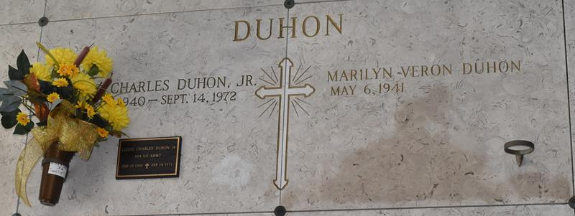

Services Held For Local Man Killed In Wreck

Funeral services for Lloyd C. Duhon Jr., 32, were held at 10 a.m. Saturday at the St. Joseph Catholic Church in Paulina, La. Interment was in the church cemetery.
Mr. Duhon was injured fatally at 8:10 p.m. Thursday when the automobile he was driving ran into the rear of a trailer tractor on the airline highway (U.S. 61) near the LaPlace Dragstrip in St. John the Baptist Parish.
State police said Duhon who was alone in the vehicle, was driving toward Baton Rouge at the time. They said the truck which was proceeding in the same direction, was driven by Edward L. Hall, 42, Houston, Texas.
Mr. Duhon is survived by his wife Marily Veron Duhon, Father of Lloyd Charles Duhon III, Douglas Duhon and David Duhon; son of Mr. and Mrs. Lloyd C. Duhon Sr., of Gramercy, La., brother of Mrs. Nolan (Yvonne) Bourgeois Jr. of Lutcher, La., also survived by 2 neices (sic) and 1 nephew, a native of Gramercy.

The News-Examiner, Lutcher, Louisiana
Thursday, September 21, 1972

