Marilyn (Veron) Duhon
May 6, 1941 - September 20, 2025

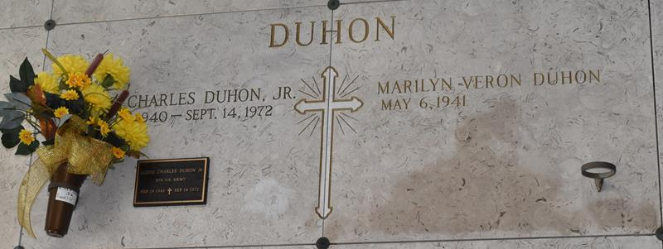

Marilyn Veron Duhon passed away peacefully surrounded by her loving family right as the noon bells rang on Saturday, September 20, 2025 at the age of 84.
Born on May 6,1941 in New Orleans, she was a native of Lutcher, LA. Beloved wife of the late Lloyd Charles Duhon, Jr. Loving mother of Douglas Duhon (Beki), David Duhon (Michelle), and the late Lloyd Charles Duhon, III. Grandmother of Chelsea Graves (Jacob), Drake Duhon (Matt), Taylor Duhon (Paige), Jordan Duhon (Kelcie), Cody Duhon (Rebacca), Matthew Duhon, Brennan Duhon (Michal), Taylor Millet (Marcus), Tamara Blanchard (John), and the late Cole Duhon. Great-grandmother of ten with four on the way. Daughter of the late Hendricks Veron, Sr and Cecile Octavie Gaudet Veron. Sister of Lynette Poche (Mahlon), Neil Veron (Kay), Daniel Veron (Sheila), the late Hendricks Veron Jr (Ina), and Gaston Veron (Yvonne). Brother-in-law Nolan Bourgeois (Yvonne). Also survived by numerous nieces, nephews and cousins.
The family is especially grateful to Tammie and Emma Lee, and the Restorative Touch Home Care Team of Karen, Bettie and Wanda for their dedication to the care of Marilyn in her final years.
Marilyn was a devoted Catholic and a committed Adorer. She was a member of St. Anne’s Alter Society, a Catholic Daughter, sang in the St. Joseph Choir and cared for the linens. She marked the major holidays surrounded by family with crawfish in the Spring and bonfires for Christmas. Marilyn worked as a book keeper for Mac Bordelon and later, with her son David at Bordelon Pest Control. She loved family dinners on Sundays, was famous for her pralines, and cared for her plants and flower beds.
Relatives and friends are invited to attend the Visitation and Funeral at St. Joseph Church on Tuesday, September 23, 2025. Visitation from 9:00 am to 11:00 am with the Funeral Mass to start at 11:00 am. Burial will immediately follow at the St. Joseph Mausoleum.

Rose Lynn Funeral Home, Lutcher, Louisiana
September 22, 2025

