Emilia M. Foret

February 9, 1898 – July 15, 1990

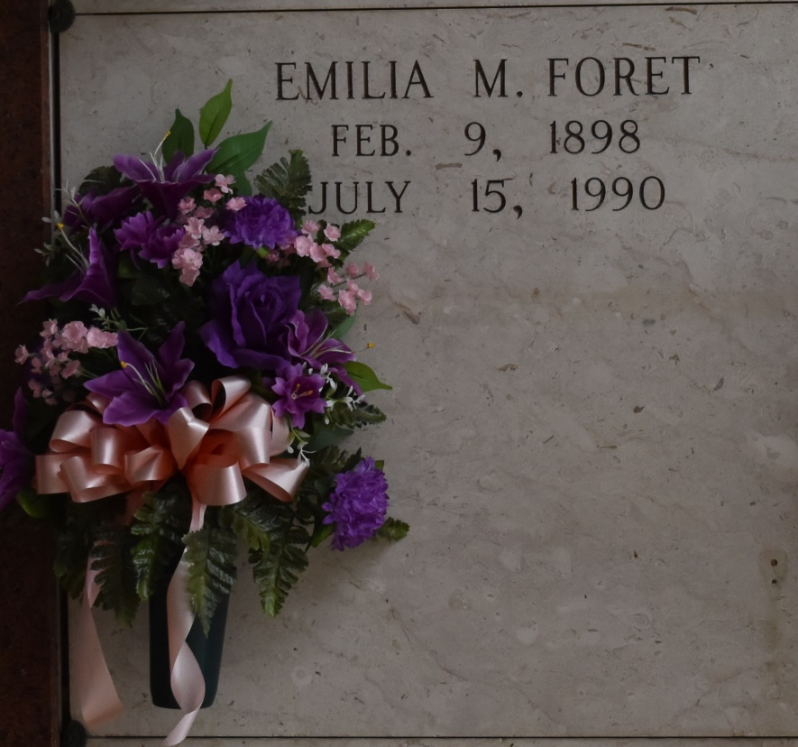

Funeral services will be at 2 p.m. today at St. Joseph Catholic Church in Paulina for Emilia M. Foret, a native of Lockport, a former resident of Lutcher and resident of New Iberia, who died Sunday. She was 92.

Visitation is at Alexander Funeral Home in Lutcher from 12:30-1:45 p.m. today. Entombment is in the church mausoleum.

She was the half-sister of Marie Phillips and Shirley Mayeaux.

She was preceded in death by her parents, Thomas Sr. and Emilia Toups Foret; brothers, Thomas Jr., John, Eugene, Charles, Teddy, Ellis and Romain Foret; sisters, Eleanor Ayo and Jean Armand and half-brother, Lloyd Foret.

Alexander Funeral Home is in charge of arrangements.

The Lafourche Daily Comet, Lafourche Parish, Louisiana

JUL 15 1990

Contributed by Chris Tidwell