Robin (Kinler) Gautreau
June 25, 1963 – April 14, 2025

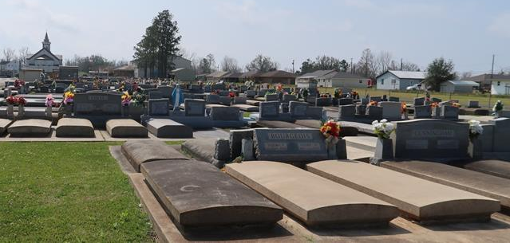

Robin Kinler Gautreau, most preciously known as Grammy, passed away surrounded by family on April 14, 2025 after a long and courageous battle with cancer at the young age of 61. She was born on June 25, 1963 to Dudley and Phenie Dottolo Kinler. She is survived by her husband of 28 years, Kyle Gautreau, her son Jordan (Brandi) Remondet, her sister, Patty (Gary) Roussel, brothers, Chuck (Jonnette) Kinler, Glenn (Kim) Kinler, her grandsons, Aysen and Baylor Remondet, several nieces and nephews, and her stepson Kolby (Taylor) Gautreau and their son Emery.
She is preceded in death by her father, Dudley “T-Dud” Kinler, her grandparents, Anthony “Tony” and Katie Dottolo, Edmond and Anita Kinler, Sr., and her in-laws, Leon “Nap” Gautreau, Peggy H. Gautreau, and Sharla M. Gautreau.
Robin lived a life serving others until her very last breath. She selflessly ensured her entire family was cared for, no matter what it demanded of her. She took great pride in raising and was so proud of her only son, Jordan, never missing a thing he took part in. She married the love of her life, Kyle, on October 18, 1996. They enjoyed many outings together, whether it was going to dinner, attending a concert, or taking a camping trip together. She later embraced a love like no other for her two grandsons, Aysen and Baylor. She loved them unconditionally and was present for every occasion. She loved attending events and beamed with pride for everything they accomplished. She and her sister, Patty, loved spending time together whether it was shopping, grabbing a bite to eat, watching the newest movie release, or just hanging out. Robin loved watching her brothers’ children grow and was always so proud of them. She never missed the opportunity to sit on her back patio and have a glass of wine with her neighbors after a long day. She will be deeply missed by her loving family and friends.
Relatives and friends are invited to attend the Visitation and Funeral Mass on Monday, April 21, 2025 at St. Joseph Church in Paulina, LA. Visitation will be held at church from 9:00 a.m. to 12:00 p.m. followed by a mass of Christian burial at 12:00 p.m. Burial immediately following in St. Joseph Mausoleum, Paulina, LA.

Rose Lynn Funeral Home, Lutcher, Louisiana
April 17, 2025

