Joan (Brien) Hauck
October 14, 1937 - April 6, 2026

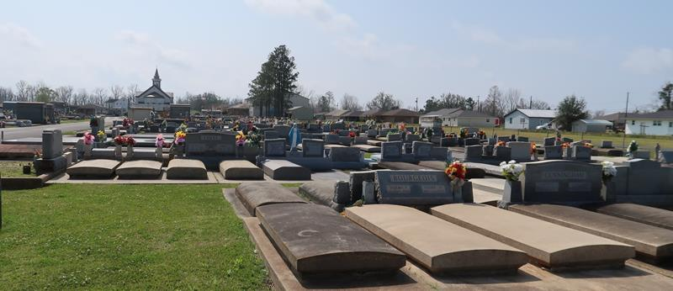

Joan Brien Hauck a resident of Gonzales, passed away on Monday, April 6, 2026 at the age of 88.
Loving mother of Tessie St. Pierre, Julie Martin, and John St. Pierre. Grandmother of Erica McCoy, Tyler Heagy, Gina Braud, Josiah St. Pierre, and Sundee St. Pierre. Great-grandmother of 12.
Preceded in death by her parents John L. Brien and Mabel B. Ganier, and her step-father Lawrence “Toot” Ganier. Her brother Jerry Brien. Her son Timothy “Timmy” St. Pierre and her grandson Jonah Roussel.
Joan enjoyed music, loved to dance, and cherished time with her family.
Relatives and friends are invited to the Visitation and Funeral Mass at St. Joseph Catholic Church, 2130 Rectory St., Paulina, LA on Friday, April 10, 2026. Rosary will begin at 9:15 am with the Visitation to follow from 9:45 am- 11:00 am, with the Funeral Mass to begin at 11:00 am. Burial to follow at St. Joseph Cemetery, Paulina, LA.
The family would like to thank the staff at Ascension Oaks and Bridgeway Hospice for their care and compassion, shown during this time.

Rose Lynn Funeral Home, Lutcher, Louisiana
April 19, 2026

