Augustin Joseph Hymel, Jr.
January 7, 1941 - March 13, 2026

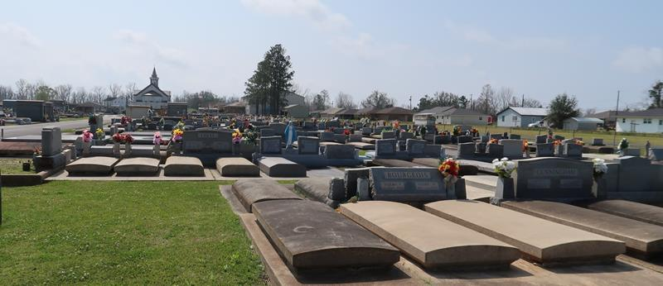

Augustin J. Hymel, Jr. (AJ), a native of Lutcher and a longtime resident of Gramercy, was born to Celine and Augustin Hymel on January 7, 1941. He passed away peacefully at home, surrounded by his loving family, after a courageous battle with Parkinson’s Disease at the age of 85 on Friday, March 13, 2026.
Augustin was the beloved and devoted husband of Arlene Roussel Hymel for 64 years. He is also survived by his children, Lisa (Wade) Faucheux, Connie (Tyler) Loupe, and Jay (Crystal) Hymel.
He was a proud grandfather to eight grandchildren: Todd Lambert (Hannah), Paul Faucheux (Brooke), Jess Lambert (Alexandra), Paige Faucheux, Catherine Loupe, Cain Lambert, and Dylan, Malorie, and Sadie Hymel. He was also blessed with five great-grandchildren: Samuel, Caroline, and Andrew Lambert, and Bentley and Breigh Faucheux. Cherished brother to the late Baby Louise Hymel, and Lois Boe (Charles).
Augustin retired as a Supervisor from Freeport McMoRan/Agrico Uncle Sam after 30 years of dedicated service. He had a deep love for sports, especially the LSU Tigers and the Lutcher High School Bulldogs, whom he faithfully followed for many years. Tailgating on game days and watching the Tigers play were traditions he treasured. He enjoyed helping prepare the food for tailgating and spending time with friends, often making them laugh with his funny jokes. Even more special to him was cheering on his grandchildren at their own sporting events.
The family extends heartfelt thanks to the staff of St. Catherine Hospice and to Paula Adams, caregiver, for the compassion, care, and comfort they provided in his final years.
Relatives and friends are invited to attend the Visitation and Funeral Mass at Sacred Heart of Jesus Catholic Church, 616 E. Main St., Gramercy on Tuesday, March 17, 2026. Visitation at the church from 9:00 a.m. to 11:00 a.m. followed by a Funeral Mass at 11:00 a.m. Interment in St. Joseph Cemetery, Paulina, LA.

Rose Lynn Funeral Home, Lutcher, Louisiana
March 17, 2026

