Virginia (Gravois) Laiche
January 12, 1941 - September 2, 2023

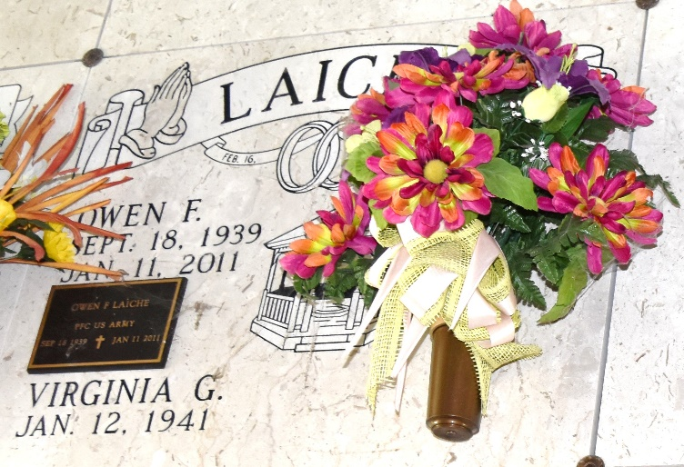

Our precious mother, Virginia Gravois Laiche, passed away Saturday, September 2, 2023. She was a native of Vacherie, resident of Paulina, and dedicated member of St. Joseph's Catholic Church. Her family was her sole focus. She loved them, worried over them, rooted for them, protected them, and took care of them until the end. She was one of a kind and to be loved by her was truly a blessing. Virginia will be desperately missed by all those that she’s left behind.
She is survived by daughter Pam Bourgeois and husband Todd; son Wade Laiche and wife Elena; son Damian Laiche and wife Nancy; daughter Becky Poché and husband Perry; sister Ann Granier and brother Allen Gravois; and a very special niece Ronnie and husband Joe, who we all jokingly and lovingly refer to as mom’s first daughter.
Virginia is also survived by eleven grandchildren, Donavan, Lacie, Kyrie, Wade Jr., Maurie, Briley, Madison, Alex, Lindsey, Seth, and Kaylee; 9 great-grandchildren, Reagan, Owen, Emery, Annie, Beau, Greyson, Aymes, Perry, and Adrianna; and numerous in-laws, nieces, nephews, and treasured friends.
Virginia was preceded in death by her loving husband of 47 years, Owen, an infant daughter Monique, parents Felix and Effie Gravois, and five siblings, Mildred Webre, Lydia Labat, Raymond Gravois, Phillip Gravois, Francis Gravois and Edwin ‘Menew’ Gravois.
Our family would like to extend our heartfelt gratitude to all of her care givers at The Claiborne and Francois Bend for the wonderful care given to her.
Relatives and friends are invited to attend the Visitation and Funeral Mass. Visitation will be at St. Joseph's Catholic Church, 2130 Rectory St., Paulina, LA on Friday, September 8, 2023 from 9:00 a.m. until 11:00 a.m. Mass of Christian Burial will be held at 11:00 a.m. at the church with Fr. Vincent Dufresne officiant. Burial will follow in the St. Joseph Mausoleum.
Rose Lynn Funeral Home, Lutcher, Louisiana
September 6, 2023

