Charleen (Dillman) Lambert
July 20, 1947 - April 16, 2025

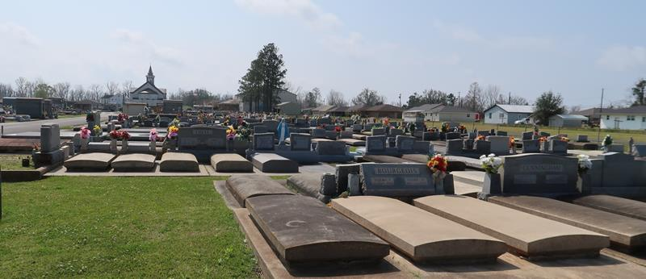

Our Sweet loving mother, Charleen D. Lambert, a resident of Gramercy, passed away on Wednesday April16, 2025 at the age of 77.
Beloved mother/mother-in-law of Robin Labranche, Jeanne Plaisance (Darren), and Patrick Copponex (Nissy). Proud grandmother of David, Jr (Felicia), Joseph (Lindsay), Meagan (Nicolas), Bethany (Gage), and Cole. Great-grandmother of Drey, Quinton, Wyatt, Nova, Owen Kate, and Reign. Sister of Rickey Morales.
She will be greatly missed by her fur-baby, Jenna, who has been at her side for 10 years.
Proceeded in death by her husbands, Ulrich Copponex, Jr and Stanley Lambert. Her grandparents who raised her from a baby, Jospeh and Rosalie Gendusa. Her parents, Sara Lee Gendusa Dutton and William J Dillman, Jr. Her brothers, William “Bill” Dillman, III and David Morales.
Relatives and friends of the family are invited to attend the visitation and Funeral Mass at St. Joseph Catholic Church, 2130 Rectory St., Paulina, LA on Wednesday, April 23, 2025. Visitation will be held at the church from 9:00 am-11:00 am followed by a Funeral Mass at 11:00am. Interment in St. Joseph Cemetery, Paulina, LA.

Rose Lynn Funeral Home, Lutcher, Louisiana
April 19, 2025

