Timothy Jude Lambert
December 14, 1956 – May 14, 2025

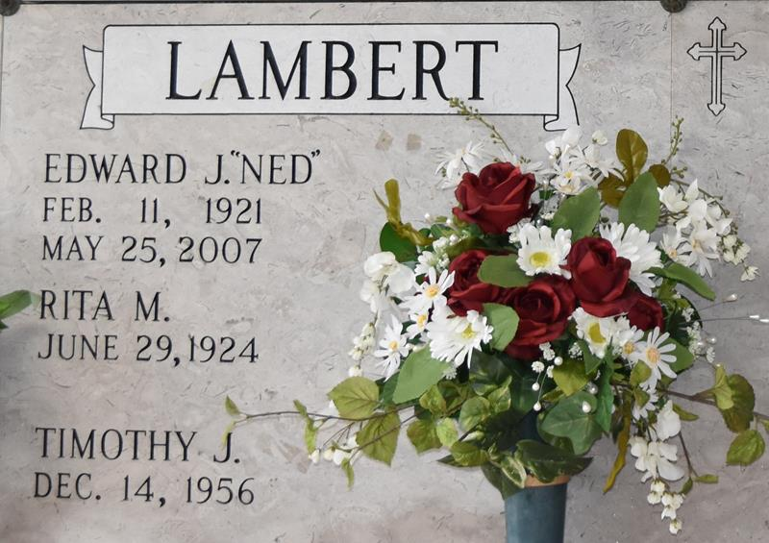

Timothy “Timmy” Jude Lambert passed away on Wednesday, May 14, 2025 at the age of 68. He was born on December 14, 1956.
Son of the late Edward Jean Lambert and Rita Melancon Lambert. Brother of Vera Poche (Murphy), Edward “Bud” Lambert (the late Patty), Dennis Lambert (the late Joy), David Lambert (Debbie), Jhan Lambert (Kathy), and Donna Hebert (the late Felix). Nephew of Gladys “Gedie” Crowe (Bill). Also survived by numerous nieces and nephews, including the late Paul Lambert, Justin Lambert, and Brad Frans.
Timmy was well known for riding his golf cart around Red Webre’s Grocery Store in Convent. Timmy had a very happy life and was so full of love.
The family would like to extend thank yous to a host of people; Dr. Jacqueline Kirby, Dr. Cullen Ocmond, St. James Parish Hospital and its staff, St. Joseph Hospice, his special aide Angelica, his wonderful sitter Anita Jones and Emily Jones for all of our daily devotions and prayers, and a special thanks to Jake Reynolds for his daily assistance.
Relatives and friends are invited to attend the Visitation and Funeral Mass at St. Joseph Catholic Church, 2130 Rectory St., Paulina on Wednesday, May 21, 2025. Visitation will be held at the church from 10:00 a.m. to 12:00 p.m. followed by a Funeral Mass at 12:00 p.m. Interment in St. Joseph Cemetery, Paulina, LA.

Rose Lynn Funeral Home, Lutcher, Louisiana
May 15, 2025

