Barry Robert LeBlanc
February 13, 1946 - March 7, 2026

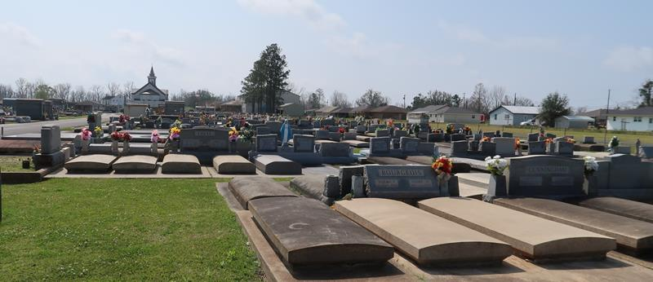

Barry Robert LeBlanc, a native of Lutcher and a long-time resident of Gramercy born to Alice and Odom "Toot" LeBlanc on February 13, 1946, passed away at Baton Rouge General Hospital at the age of 80, on Saturday, March 7, 2026 surrounded by his loving family.
Barry was the beloved and devoted husband of Caroleen Bourgeois Michel LeBlanc for 50 years and a loving brother to Tammi Falgoust (Brian). Barry was a proud stepfather to Rhonda (Paul) Laroze and Susan (Tommy) Laroze, a loving Godfather to Brandi (Chris) Bourgeois and uncle to Kaci (Josh) Crowder. Barry was a devoted great uncle to Kole and Kori Bourgeois and Lawson and Kyli Crowder who all called him "Parin".
He is also survived by his step grandchildren Tony, Jill (Pic), Mike, Michelle who all called him "Paw" and their children Kain, Ashton, Alix, Layla, Myla, Colton who called him "Pappy". His other grandchildren are Cierra, Ellie, Holden and Beckett. Barry also leaves behind his adorable dog "Prissy". Barry enjoyed going to New Orlean Saints football games on Sundays, camping with Caroleen in the motor home with their camping friends, and most importantly spending time with his family. He found the most joy in working in his yard, washing all his cars, riding around town visiting friends, and dancing with Caroleen to Swamp Pop Music. Barry worked for the Gramercy Kaiser Plant for many years and then the St. James Parish Sherrif's Office where he retired from a job that allowed him to do things he loved - drive around town and talk to people in the community.
Relatives and friends are invited to celebrate Barry's life at Sacred Heart Church, 616 Main Street, Gramercy, La 70052 on Wednesday, March 11, 2026. Visitation will be from 9:00 am to 11:00 am, followed by a Funeral Mass at 11:00 am. Interment will follow at St. Joseph Cemetery 2130 Rectory Street, Paulina, La 70763.

Rose Lynn Funeral Home, Lutcher, Louisiana
March 17, 2026

