Junius N. LeBlanc
September 18, 1939 – October 20, 2013

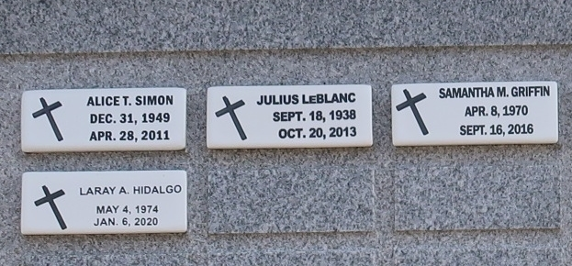

LeBlanc: Junius "Sonny Boy" LeBlanc: Died Sunday, Oct. 20, 2013 in Lutcher, LA. He was 75, a native and resident of Lutcher. Visiting at St. Joseph Catholic Church in Paulina, LA from 10:00am to Mass of Christian Burial at 11:00am Friday, Oct. 25, 2013. Survived by 1 brother, Donald LeBlanc; his caregiver, Theresa Williams and a host of nieces, nephews other relatives and friends. Preceded in death by his parents, Shedrick and Evelina LeBlanc. and a son, Julius LeBlanc.

Wiliams & Southall Funeral Home, Napoleonville, Louisiana
**

Junius "Sonny Boy" LeBlanc, 75, a native and resident of Lutcher, died Sunday, Oct. 20, 2013. Visitation will begin at 10 a.m. Friday at St. Joseph's Catholic Church followed by a Mass of Christian burial at the church cemetery. He is survived by a brother, Donald LeBlanc. He was preceded in death by his parents, Shedrick and Evelina LeBlanc; and son, Julius LeBlanc. Williams and Southall Funeral Home is in charge of arrangements.

Houma Today, Terrebonne Parish, Louisiana
Oct. 23 to Oct. 24, 2013
**

U.S., Social Security Death Index, 1935-2014
Name Junuis N Leblanc
Social Security Number xxx
Birth Date 18 Sep 1939
Issue year 1954
Issue State Louisiana
Death Date 20 Oct 2013

