Joseph Harry LeBoeuf

April 14, 1924 – September 28, 2008

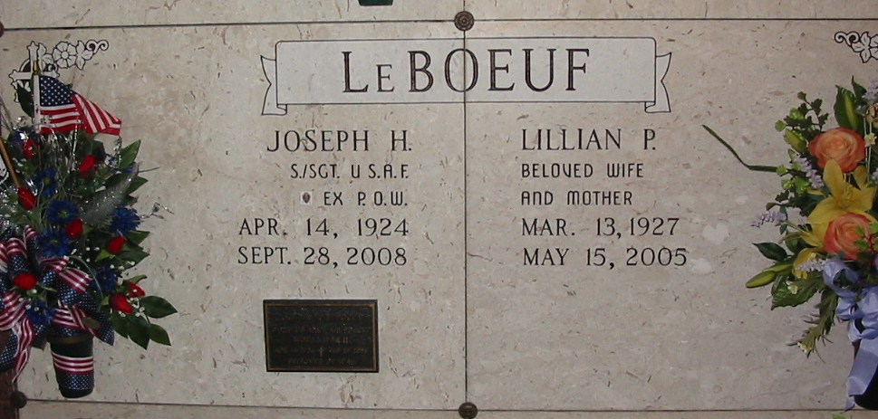 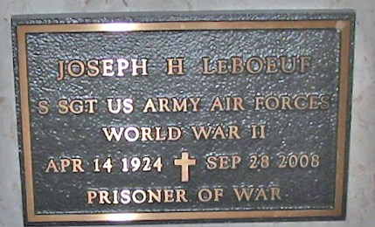

Photos by Bobby

Joseph Harry LeBoeuf passed away on Sunday, Sept. 28, 2008, at the Southeast Louisiana War Veterans Home in Reserve. He was 84, a native of Lions and a resident of Lutcher for many years.

He was the beloved husband of the late Lillian Poche LeBoeuf, father and father-in-law of Chris and Maureen LeBoeuf, of Thibodaux, and Emelie "Tootsie" and Tom Larsen, of Ponchatoula, grandfather of Christopher LeBoeuf, of Thibodaux, Hollie Zeringue, of Gramercy, Stacey Roussel, of Sugarland, Texas, and Brett Larsen, of Monroe, great-grandfather of Caleb Zeringue, Emelie and Jessie Clare Roussel, Phoebe and Benjamin Joseph LeBoeuf and Remy Larsen, son of the late Agatha Michel LeBoeuf and Joseph H. LeBoeuf, and brother of Rosemary L. Roussel and Russell LeBoeuf.

He was a life member of the East St. James Veterans of Foreign Wars Post 5852, X-POW D.A.V. life member. He was retired from Kaiser Chemical & Aluminum.

Relatives and friends of the family may visit at St. Joseph's Catholic Church, Paulina, on Wednesday, Oct. 1, from 9 a.m. until Mass of Christian Burial at 11 a.m. Entombment in St. Joseph's Mausoleum. Arrangements by H.C. Alexander Funeral Home, Lutcher. Friends and relatives are encouraged to leave their thoughts and fond memories in the guestbook at www.mem.com.  
  
Published in The Advocate, Baton Rouge, Louisiana

September 30, 2008