Lillian (Poche) LeBoeuf

March 13, 1927 – May 15, 2005

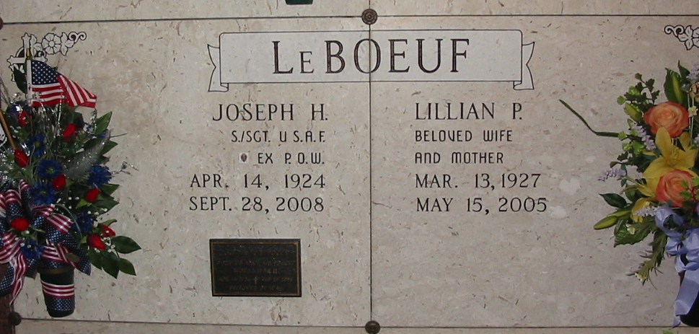

Photo by Bobby

Lillian Poche LeBoeuf died Sunday, May 15, 2005, at St. James Parish Hospital. She was 78 and a lifelong resident of Lutcher.  
 She was the beloved wife of Joseph Harry LeBoeuf of Lutcher, mother and mother-in-law of Chris and Maureen LeBoeuf of Lutcher and Emelie "Tootsie" and Tom Larsen of Ponchatoula, grandmother of Christopher LeBoeuf of Thibodaux, Hollie Zeringue of Gramercy, Stacey Roussel of Houston and Brett Larsen of Monroe, great-grandmother of Caleb Zeringue, Emelie and Jessie Clare Roussel, Phoebe and Benjamin LeBoeuf and Remy Larsen, daughter of the late Albert Poche Sr. and Emilie Battard, adopted daughter of the late Remy J. Poche and Antoinette Battard Poche, and sister of Marie Louise Deslatte of Norco, and the late Albert Poche Jr., Raymond Poche, Jules Poche, Clarence Poche, Amy P. Raffray, Julie P. Surmik, Eleanor P. Miller and Odette P. Kilburn.  
 She was past auxiliary president of the East St. James VFW Post 5852, member of St. Ann Altar Society and AARP and a retired employee of the News Examiner. Relatives and friends of the family may visit at St. Joseph's Catholic Church, Paulina, from 9 a.m. Thursday, May 19, until funeral Mass at 11 a.m.  
 H.C. Alexander Funeral Home, Lutcher, is entrusted with the arrangements.

Published in The Advocate, Baton Rouge, Louisiana

May 18, 2005