Adele B. Loupe

February 16, 1900 – July 1, 1979

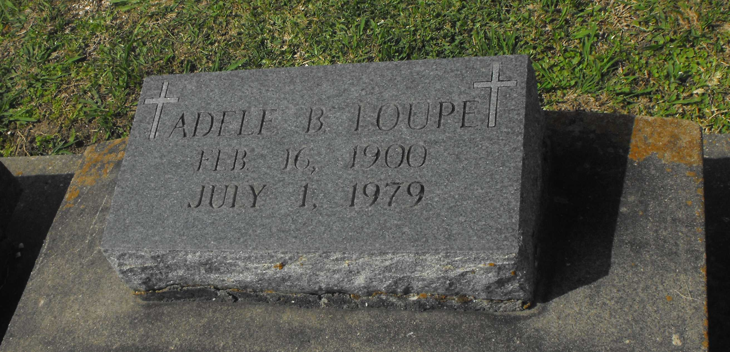

Photo by Mary Agnes Hammett

LOUPE

Adele B. Loupe, on Sunday, July 1, 1979 at 5:40 p.m., daughter of the late Donatile Bourgeois and Charles Loupe; sister of the late Ida Loupe Roper; age 79 years, a native and resident of Paulina, LA.

Relatives and friends of the family areinvited to attend the funeral. Services from the Alexander Funeral Home, 107 Jefferson Highway, Lutcher, LA, on Tuesday, July 3, 1979 at 2 o’clock p.m. Religious services St. Joseph Catholic Church, Paulina, LA.

Interment Church Cemetery. Friends may call from 5 o’clock p.m. until 11 p.m. on Monday.

The Times-Picayune, New Orleans, Louisiana

Monday July 2, 1979, Section 1, p. 24