Palmyre (Badeaux) Loupe

February 14, 1904 – November 15, 1961

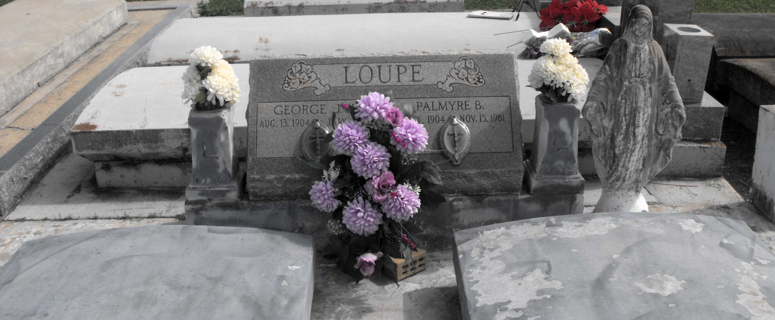

Photo by Mary Agnes Hammett

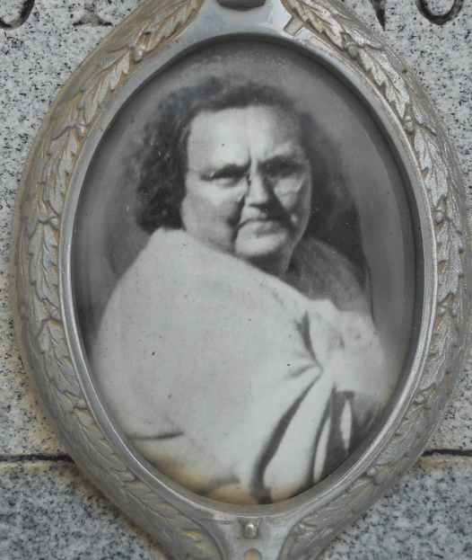

Photo by Team TLo

On Wednesday, November 15, 1961 p.m., Palmyre Badeaux, beloved wife of George Loupe and mother of Mrs. Nolan (Olive) Deroche and Alvin (Gloria) Loupe, also survived by six grandchildren (Nolan Jr. and Karen Deroche, Barbara, Peggy, Paul, and Janice Loupe), age 57; a native of Convent, LA, and a resident of Gramercy, LA.  
 Relatives and friends of the family are invited to attend the funeral. Services from Alexander Funeral Home, Lutcher, LA on Saturday, November 18th at 8:45 a.m. Religious services at the Sacred Heart Church, Gramercy, LA at 9:00 a.m. Interment in the St. Joseph Cemetery, Paulina, LA.  
  
The Times-Picayune Newspaper, New Orleans, Louisiana  
Saturday, November 18, 1961 / Section One, Page Two