Lorna (Veron) Louque
November 01, 1937 - August 02, 2025

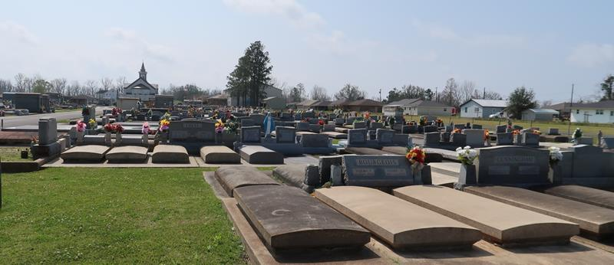

Lorna Veron Louque a resident of Lutcher, passed away on Saturday, August 2, 2025 at the age of 87.
Beloved wife of Willie Louque, for 69 years. Loving mother of Bertha Triche (Douglas), Lawrence “Loga” Louque (Eileen), and the late Lorna Ann Louque. Grandmother of Erin Triche, Taylor Triche (Dean), Emilie Triche, Nathan Louque (Meghan), Alicia Plessala (Ryan), and Jessica Louque. Great-grandmother of Rylin Plessala, Remi Plessala, Nicholas Louque, Annalise Louque. Daughter of the late Jumonville Veron and Bertha Brignac Veron. Sister of Estelle Weil, Jeanne Melancon (Jesse), the late Odile Brignac, Ernest Veron, JP Veron and Patsy Veron. Also survived by numerous nieces, nephews, and cousins.
Relatives and friends are invited to attend the Visitation and Funeral Services at St. Joseph Catholic Church, 2130 Rectory St., Paulina, LA 70763, on Saturday, August 9, 2025. Visitation will be held from 8:00 am-10:00 am with the Funeral Mass to begin at 10:00 am. Burial will immediately follow the services in St. Joseph Catholic Cemetery.
In lieu of flowers, the family requests that donations be made to St. Peter of Chanel Interparochial School.

Rose Lynn Funeral Home, Lutcher, Louisiana
August 7, 2025

