Dale Anthony Martin Sr.
January 16, 1959 - August 21, 2025

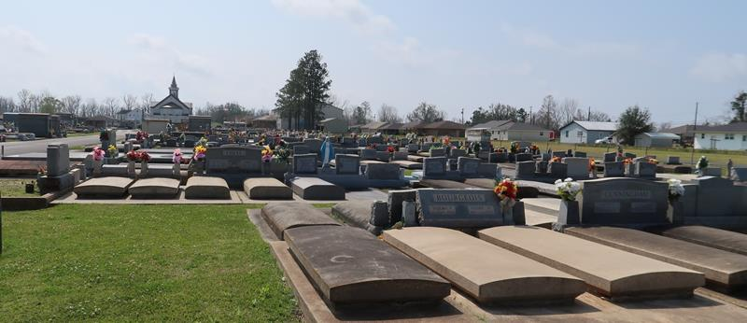

Dale "Bruno" Anthony Martin, Sr. passed away on Thursday, August 21, 2025, at the age of 66. A lifelong resident of Paulina, LA. A former pipeline worker and truck driver for many years.
Beloved husband of Christine Martin. Loving father of Meggie Duhe (John), Nicole Schubert (A.J.), and Dale Martin, Jr. (Emily). Grandfather of Nathan Duhe, Owen Duhe, Presley Duhe, Emma Schubert, Laila Schubert and Sutton Martin. Son of the late Harry Martin , Sr. and Stella Rome Martin. Brother of Dianne Matherne (Glenn), Harry Martin, Jr. (Rose), Sandra Kliebert (Louis), Danette Alleman (Bert), and the late Keith Martin (Cindy) and Donald Martin. Uncle of the late Jason Martin. Godfather of Joey Matherne and Kolby Martin. Also survived by numerous nieces, nephews, and cousins.
Family would like to express their heartfelt appreciation to his nurses from Egan Ochsner Home Health and Compassus Hospice.
Relatives and friends are invited to attend the Visitation and Funeral Mass at St. Joseph Catholic Church, 2130 Rectory St., Paulina, La on Thursday August 28, 2025. Visitation at church from 9:00 am to 11:00 am followed by a Funeral Mass at 11:00 am. Interment in St. Joseph Cemetery.

Rose Lynn Funeral Home, Lutcher, Louisiana
Aug. 22, 2025

