Kathleen "Kitty" (Schexnayder) Martin
March 3, 1937 - May 13, 2026

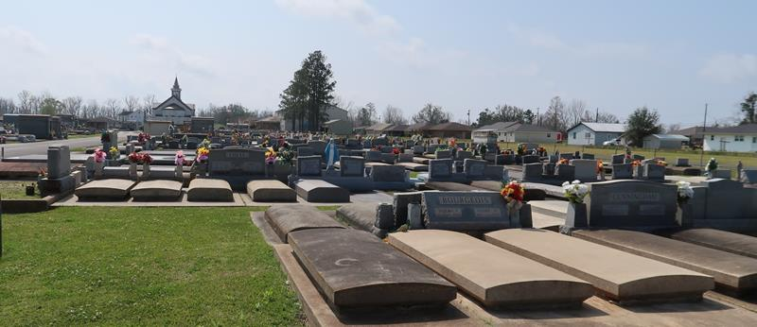

Kathleen “Kitty” S. Martin entered her eternal rest on May 13, 2026, at the age of 89. She was a native of Gramercy, Louisiana, and later in life resided in Gonzales, Louisiana.
Kitty had many passions throughout her lifetime and also had various hobbies. These included eating and/or cooking meals with families and friends, dancing, crafting, playing bingo, and most of all, spending time with her children and grandchildren.
She is survived by her children, Patrick Martin, Jr. (Tammy), Maureen Matherne (Mitch), Coleen Hotard (Callen), and Eileen Miller (Dave); grandchildren, Devin (Kaylie), Whitney (Brett), Kayne (Bridget), Bryce (Danielle), Cody (Alecia), Carly (Rusty), Fabyan, Kayln (CJ), Cayde (Caitlin); fifteen great-grandchildren; and her siblings, Lionel Schexnayder, Jr., Thomas Schexnayder, Francis Perret, and Diane Tramonte.
Kathleen is preceded in death by both her first and second husband, Patrick Martin and LeDaine Summers; her son, Dennis Martin; her parents, Lionel and Agnes D. Schexnayder; as well as her sisters Drucilla Tr. Carbo, Joyce Diez, Doreen Schexnayder, and Joan S. Troscliar.
Family and friends are invited to attend a Visitation and Funeral Mass on Monday, May 18, 2026, at St. Joseph Catholic Church, located at 2130 Rectory St, Paulina, Louisiana 70763. The Visitation will be held from 9:00 a.m. until 11:00 a.m., and the Funeral Mass will begin at 11:00 a.m. Burial will follow immediately after at St. Joseph Catholic Church.

Rose Lynn Funeral Home, Lutcher, Louisiana
May 18, 2026

