Olivia (Babin) LeBlanc - McLean

April 18, 1922 – August 13, 2008

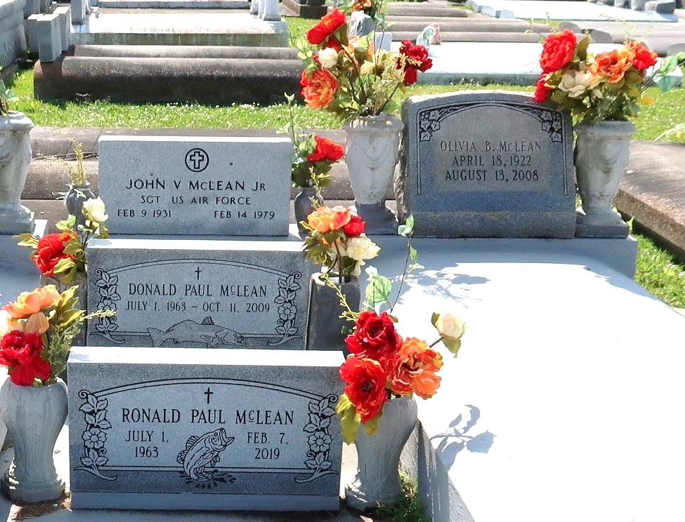

Olivia Babin LeBlanc McLean, 86, died August 13, 2008. She is the daughter of the late Olivia and Cyril Babin, wife of the late Usley LeBlanc and John V. McLean II, sister of Cyril Babin and the late Marie Louise Babin and Josephine Zeringue.

Special thanks are given to Octvia, Lula, Annie and Glenda of Home Care of LaPlace.

Visitation will be held Saturday, August 16, from 8 a.m. to 9:30 a.m., at H.C. Alexander Fuenral Home, Lutcher, La. A religious service will follow at 10:00 a.m. Saturday at St. Joseph Catholic Church, Paulina, LA. Interment will follow in the Church Cemetery.

L’Observateur, LaPlace, Louisiana; Friday, August 15, 2008