Reginald "Reggie" Paul Melancon
November 07, 1952 - July 04, 2025

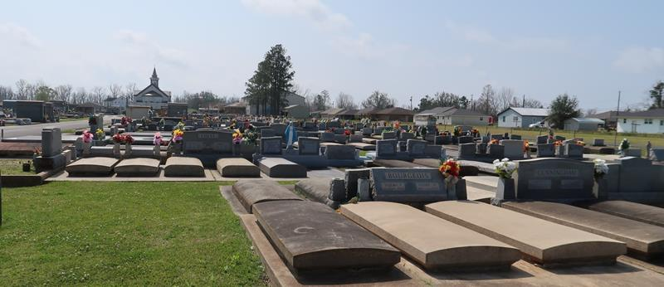

Lieutenant Colonel Reginald Melancon, a native of Thibodaux and resident of Paulina, passed away peacefully and surrounded by his loving family on July 4, 2025 at the age of 72.
Reggie was a graduate of Thibodaux High School and Nicholls State University, with graduate work at Nicholls, University of Northern Colorado and the Army's Command General Staff College. He served his country proudly in the US Army. Reggie was awarded numerous awards including the prestigious Meritorious Service Medal twice and the Joint Service Commen-dation Medal. He retired from the military after serving our country for 30 years. Reggie continued his career in logistics, working for Kaiser Aluminum, LaRoche Industries, and Safeway Transportation. Reggie enjoyed traveling with family and friends. Reggie had a passion for playing his guitar and writing his own music. He enjoyed hunting, fishing, and gardening and was an avid LSU fan. His greatest joy was his six grandchildren and attending to their many events. He was an active member of St. Joseph's Church and a retired Eucharistic Minister.
Reggie is survived by his loving wife of 52 years, Brenda Melancon Melancon. Loving father of Jennifer Vosburg (Ryan), Dr. Michelle LeBlanc (Ken), and grandfather of Tyler, Luke, and Nicholas Vosburg and Kate, Landree, and Korryn LeBlanc. Brother of Earl J Melancon, Jr. (Pam), Ronnie Melancon (Rhonda), Craig Melancon (Stephanie), and Steven Melancon, brothers in law, Dr. David Melancon (Shirley), Randall Melancon (Lisa), Dr. Daniel Melancon (Gayle), and sister in law JoEllen Bourgeois (David), and numerous nieces and nephews.
Reggie was preceded in death by his parents, Earl J and Elizabeth “Dell” Melancon, Sr., brother Larry Melancon, niece Lindsey Melancon, and father in law Lawrence Melancon, Jr.
Visitation will be held Wednesday, July 9th, 2025 from 8:30 am-11:00 am with Mass to start at 11:00 am at St. Joseph’s Catholic Church, 2130 Rectory St, Paulina, LA 70763. Interment will follow after the Funeral Mass at St. Joseph Cemetery.
The family would like to extend their gratitude to Compassus Hospice and caregivers, Tiffhany, Sonya and Kendra for their kind and compassionate care.

Rose Lynn Funeral Home, Lutcher, Louisiana
July 9, 2025

