Rosalie K. Miculek
October 7, 1927 – June 6, 2023

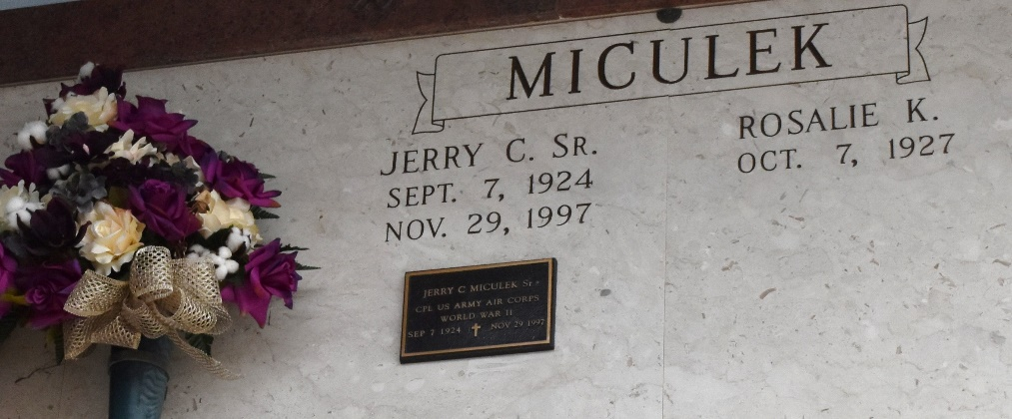

Rosalie K. Miculek passed away June 6, 2023, at the age of 95. She is preceded in death by her husband of 50 years, Jerry C. Miculek, Sr., her son James E. Miculek, daughter-in-law Christine V. Miculek, and her siblings, Aileen Drozd and Eddie Kolafa.
She is survived by her children, Michael D. Miculek (June), Jerry C. Miculek, Jr. (Kay), Donald W. Miculek (Wanda), and Patrick A. Miculek (Lisa). Grandchildren, Shelley Wagner, Miranda Miculek, Leslie Miculek, Donna Mic-Law, Holly Miculek, Amber Miculek, Justin Miculek, Lena Miculek, Gillian McCarroll, Garrett Miculek. She is also survived by her great-grandchildren, Haden, Evan, Amber, Sabrina, and Zachary.
Rosalie was a great cook and a lover of all animals, rehabilitating any and all living creatures. She will be remembered always as a very devoted mother and grandmother.
A Mass of Christian Burial will be held on Friday, June 9, 2023 at St. Joseph Catholic Church in Paulina, LA beginning at 11AM, public visitation to begin at 9AM. Burial to take place in the church cemetery immediately following Mass.
In lieu of flowers, please consider making a donation in Rosalie’s name to your local Animal Rescue.

H.C. Alexander Funeral Home, Norco, Louisiana; July 31, 2023

