Charles Philip Miller
October 29, 1969 - June 25, 2025

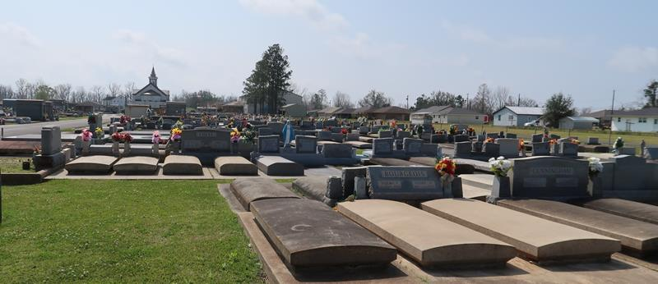

Charles Philip Miller, a resident of Baton Rouge, Louisiana, passed away on Wednesday, June 25, 2025, at the age of 55, surrounded by his family after a brief illness.
Charles was a truly special soul—not just because he was born with Down syndrome, but because of the pure joy, kindness, and light he brought into the world. His laughter was infectious, and he found happiness in life’s simplest pleasures: a meal from McDonald’s, a cold Coca-Cola with a straw, the excitement of finding $1 bills in a birthday card, or rocking contently in his favorite Lazy-Boy chair until it could rock no more. Charles loved his family deeply and left a lasting impression on everyone blessed to know him. His joy was genuine, and his love was unconditional.
We take comfort in knowing that Charles is now reunited in heaven with his loving parents, embraced in the arms of our Lord. Though our hearts ache with his passing, we rejoice in the promise that he is whole, at peace, and surrounded by everlasting love.
Charles is survived by his sister, Denise Young (Jim); brother, David Miller (Jessica); as well as his nieces and nephews, Alex Young, Austin Young, Addie Young, Minka Miller, and Maddox Miller. He is preceded in death by his parents Carl Robert Miller and Kathy Rome Miller; grandparents George Rome, Sr., Rose Mae Vicknair Rome, Carl Philip Miller, and Irene Prieto Miller.
The family extends heartfelt thanks to the Curran group home and Heritage Manor for their compassionate care of Charles after the loss of his parents. We are also grateful to Baton Rouge General for their care during his brief illness.
Visitation will be held at St. Joseph Catholic Church in Paulina, Louisiana, on Monday, June 30, 2025, from 9:00 AM until the Mass of Christian Burial at 11:00 AM. Interment will follow at St. Joseph Catholic Church Cemetery.

Rose Lynn Funeral Home, Lutcher, Louisiana
June 30, 2025

