Carolyn A. (Monroe) Millet

January 6, 1943 – December 29, 2020

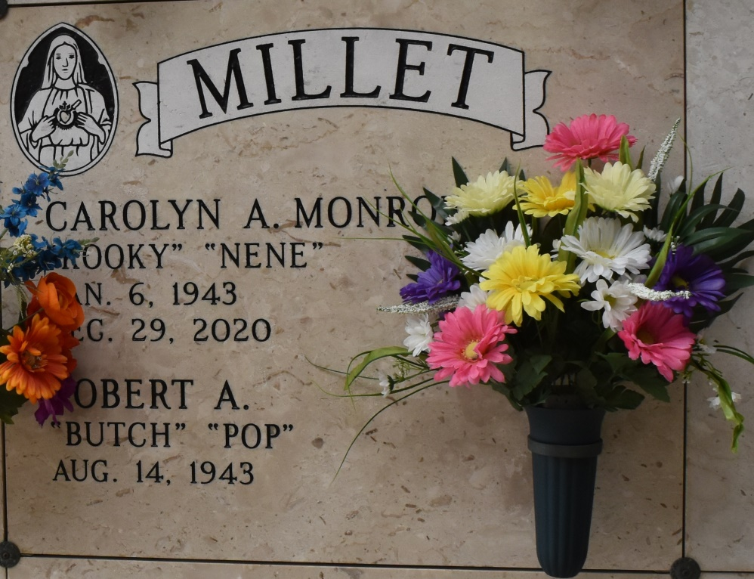

Carolyn “Kooky” Millet, a resident of Paulina, passed away on Tuesday, December 29, 2020 at the age of 77.

She is survived by her husband of 53 years, Robert “Butch” Millet Sr.; sons, Dr. Robert Millet Jr. (Ginny), Roussel “Rou” Millet (Stephanie) and Rene Millet (Patty); grandchildren, Mary Hunter, Rhyannon, Aaron and Mia; and siblings, Mary Ellen Monroe, William “Bill” Monroe and Angie Mire.

She is preceded in death by her parents, William and Marie Monroe.

A private visitation will be held in her honor. Rose Lynn Funeral Services has been entrusted with handling her arrangements

Rose Lynn Funeral Home, Lutcher, Louisiana