Maelise Elizabeth (Lambert) Millet

January 20, 1939 - February 21, 2025

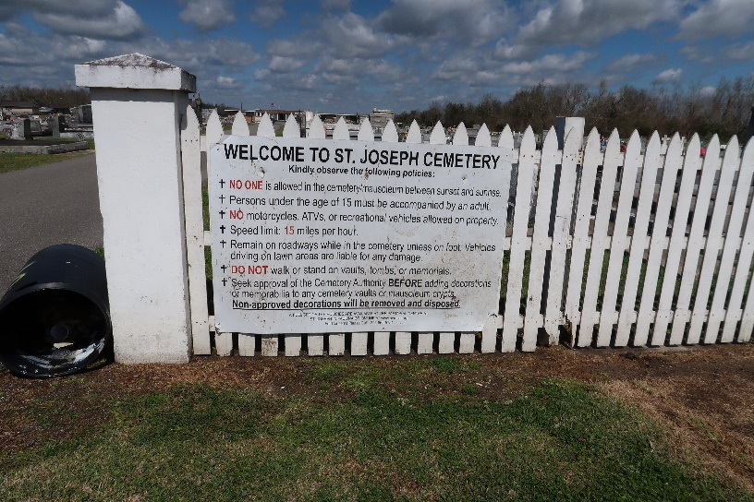

Maelise Elizabeth Millet, age 86, passed away on February 21st, 2025. She was born in St. Amant, LA, and was a longtime resident of Gramercy, LA.

For 36 years, Maelise worked as a dedicated bus driver for the St. James Parish School Board. She loved every child she picked up and treated them as if they were her own, always greeting them with kindness and watching over them as they grew. She had a wonderful relationship with her coworkers, building lifelong friendships along the way.

Above all, Maelise cherished her family. She found her greatest joy in spending time with them, especially during their Sunday lunches, surrounded by laughter and love.

She was the beloved wife of the late Larry P. Millet and a devoted mother to Randy Millet (Angela), Sandra Alleman (Randy), Jamie Melancon (Wyade), Debbie Faucheux (Joey), Peggy Oubre (Maurice "Boo"), and Shelly Poche (Murray). She was a proud grandmother to 13 grandchildren and 18 great-grandchildren, all of whom she adored.

Maelise is preceded in death by her husband, Larry, her son, Arnold P. Millet, her parents, Elie and Lize Lambert, her sisters, Nettie Gautreau and Gertie Dixon. She is survived by her sister, Nita Gaudin, along with many nieces, nephews, and loving relatives.

Family and friends are warmly invited to gather on Wednesday, February 26th, at Sacred Heart Catholic Church, 616 E Main St., Gramercy, LA, to honor and celebrate a life well lived. Visitation will be held at the church from 8:00 a.m. to 12:00 p.m. with a Mass of Christian Burial immediately following at 12:00 p.m. Interment will follow at St. Joseph Cemetery in Paulina, LA, where final respects will be paid.

Maelise lived a full life, filled with love, laughter, and a deep devotion to those around her. Her kindness and warmth will be deeply missed, but her legacy of love will live on in the hearts of all who knew her.

Rose Lynn Funeral Home, Lutcher, Louisiana

February 23, 2025