Martha Mildred (Slie) Nosacka
February 22, 1931 – June 7, 2025

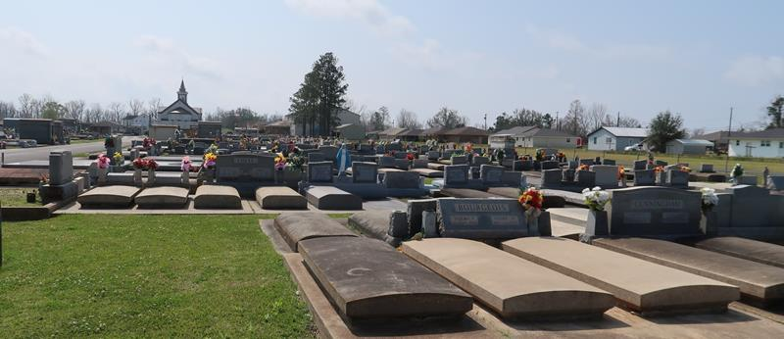

Martha Mildred Slie Nosacka, of Gramercy, La. and St. James Parish, passed away on June 7, 2025, in Baton Rouge, La. She was the beloved mother of eight children and their spouses, 27 grandchildren, and 34 great grandchildren, leaving a legacy of compassion, spiritual practice, community participation and service to others.
She was born February 22, 1931, in New Orleans, attended Holy Angels High School, and married Stephen Anthony Nosacka in 1950. They moved to Gramercy, La. in 1957, where Stephen was employed at Colonial Sugars refinery. She was well known in the community through both her work through Sacred Heart Catholic Church and her 20 years of service at the U. S. Post Office in Gramercy, La.
Martha was a lifelong, practicing Catholic with particular interest in theology and Marist traditions (i.e. the pursuit of academic excellence, the heritage of Catholic education, and the spirit of the Society of Mary); and she was open to and respectful of other spiritual traditions. She enjoyed travel and adventure and especially loved the Christmas Eve bonfires on the levee in St. James Parish. Martha was renowned for her fine French cooking and baking. Up until her later life, she cooked for and hosted most family gatherings. She was truly the "glue" that held her large family together.
She was a loving mother and moral compass for her eight children and their spouses: Catherine, Susan (Catherine), Steven (Cindy), Thomas (Lauren), Mark (April), James (Alicia), John (Barbara), and David (Catherine). She had a calm, nurturing steadfastness that guided her children as they explored their paths and raised their families. Her gifts to her children, grandchildren, and great grandchildren are present in our hearts and will continue to shape our lives.
Relatives and friends are invited to attend the Visitation and Funeral Service on June 12, 2025. Visitation will be held from 9:00 a.m. to 11:00 a.m., at Rose Lynn Funeral Home, 1870 Cabanose Ave. Lutcher, LA 70071. The Funeral Mass will begin at 12:00 p.m. at Sacred Heart Church, 616 E. Main St. Gramercy, LA 70052. Interment will follow immediately after at St. Joseph Cemetery, 2130 Rectory St. Paulina, LA 70763.

Rose Lynn Funeral Home, Lutcher, Louisiana
June 13, 2025

