Elodie (Berthelot) Pertuis

April 3, 1874 – February 22, 1957

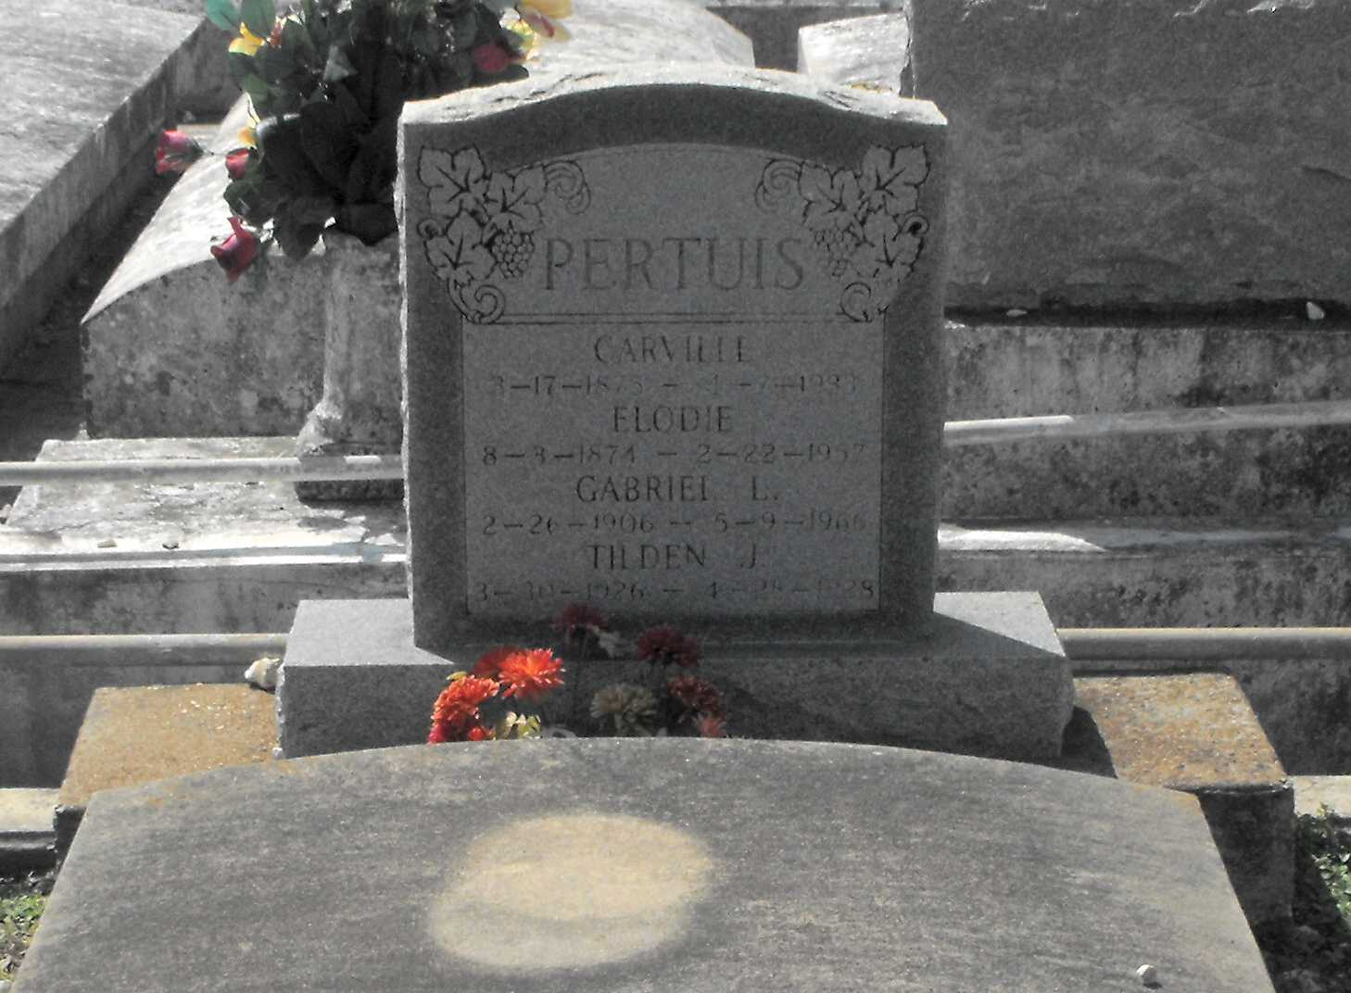

Photo by Mary Agnes Hammett

PERTUIS – In New Orleans, La., on Friday, February 22, 1957, at 1:50 o’clock p.m., Elodie Berthelot, beloved wife of the late Carville Pertuis; mother of Mrs. Walter Millet of Jacksonville, Fla., Mrs. Frederick Roper of Lutcher, La., Mrs. Alonzo Menuet of Gramercy, La., Rodney of New Orleans, La., Robert and Lester Pertuis, both of Gramercy, La.; also survived by 10 grandchildren and 17 great-grandchildren; a native of Paulina, La., and a resident of Gramercy, La., for a number of years; aged 82 years.

Relatives and friends of the family are invited to attend the funeral, which will take place from the Alexander funeral home, Lutcher, La., on Sunday, February 24, 1957, at 11 o’clock a.m. Religious services at St. Joseph’s church, Paulina, La.

Interment in St. Joseph’s cemetery, Paulina, La.

The Times-Picayune, New Orleans, LA; Saturday, February 23, 1957, p. 2