Betty (Najolia) Peytavin
December 21, 1932 - June 4, 2026

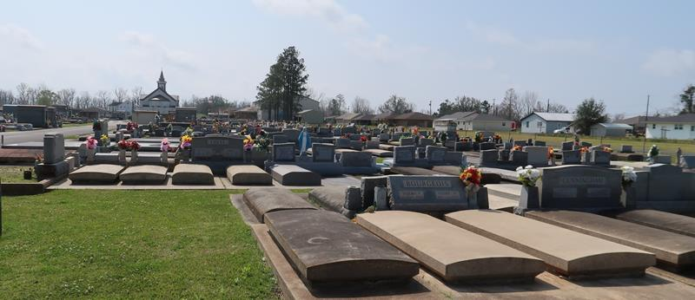

Betty Najolia (Honey) Peytavin passed away at her home in Lutcher, Louisiana, on June 4, 2026, at the age of 93, after a long illness. She was born on December 21, 1932, in Chalmette, Louisiana, and attended The Academy of Holy Angels in New Orleans. She later received a Bachelor’s Degree in Education at Loyola University, and was an Educator from 1956 until her retirement in 1998. During that time, she primarily taught children in St. James Parish.
In 1956, she married John L. Peytavin, and together they raised a family of seven children and lived in Lutcher until his death in 2015.
Her retirement from teaching did not end her public service. She became a Homebound Minister and a Marist Laity member who cooked for the St. Vincent DePaul Kitchen in Baton Rouge. She also was an Honorary Member of the Catholic Daughters, St. Ann Altar Society, and the St. James Retired Teachers Association. Honey also enjoyed traveling, spending time with her children and grandchildren, playing pokeno, and attending the St. James Parish Senior Citizen’s Center.
She is survived by her seven children and their spouses and significant others; Stephen (Jeanne), Michael (Jenny), Malcolm (Celeste), Gerard (Jenny McClung), Mark (Tanya), Anna Laurie, and Lance (Anne); eighteen grandchildren and eight great-grandchildren.
She was preceded in death by her beloved husband of 59 years, Judge John L. Peytavin; her parents, Dominic D. and Anna C. Najolia; her brother, Anthony D. Najolia; her sister, Lois Najolia Pujol; and her grandson, Jonathan M. Dencausse.
The Peytavin family sincerely thanks Modern Hospice, Honey’s caregivers, Ms. Donna Rogers and Raffieal Jackson, and her Homebound Ministry angels and friends for the care and compassion they provided to Honey during her final years.
Relatives and Friends are invited to attend a Visitation and Funeral Mass on Tuesday, June 9, 2026, at St. Joseph Catholic Church, located at 2130 Rectory St. Paulina, Louisiana 70763. Visitation will be held from 9:00 a.m. until 11:00 a.m. The Funeral Mass will begin at 11:00 a.m., and interment will follow at St. Joseph Catholic Cemetery in Paulina.

Rose Lynn Funeral Home, Lutcher, Louisiana
June 8, 2026

