Carl J. Poche, MD
September 22, 1932 – May 19, 2026

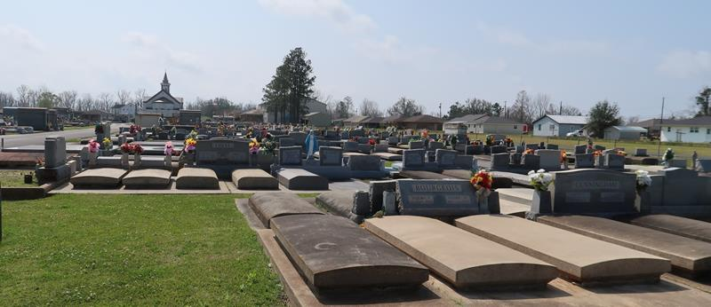

Dr. Carl J. Poche’ passed away peacefully at his home on May 19, 2026, after a prolonged battle with Parkinson’s disease. He was 93 years old.
Born on September 22, 1932, Dr. Poche’ devoted his life to medicine, faith, family, and community. A lifelong resident of the community he loved and proudly called home, he spent more than five decades serving generations of families with compassion, dedication, and kindness.
Dr. Poche’ graduated from LSU Medical School in New Orleans in 1956 and completed his internship at Charity Hospital. He later joined the United States Army and proudly served as a Captain in Germany. Dr. Poche’ returned home in 1959 and began a 52-year career serving generations of families in the community he loved. Together with his sons, Dr. Randall and Dr. Jerry, he created a family medical practice that faithfully cared for generations within the community. He was also proud to have raised two nurses, Brenda and Susan, as well as Enid, a physical therapist, and Paula, a medical office manager, all of whom shared his passion for caring for others.
Dr. Carl became a familiar and trusted presence throughout the community through his work as Coroner and as the longtime team physician for Lutcher High School athletics. He especially enjoyed LSU football and baseball and proudly supported Lutcher High athletics throughout his life. His passion for sports began at an early age, playing football, baseball, and basketball at Lutcher High School before continuing his baseball career at Loyola University and later playing semi-professional baseball for the Lutcher Cardinals. He also enjoyed golf outings with friends, fishing trips, and the countless lifelong friendships he made along the way.
His faith, generosity, and servant’s heart touched countless lives throughout the community. A devoted Catholic and committed adorer, Dr. Poche’ was an active member of the Knights of Columbus, where he held the rank of Fourth Degree Knight, as well as the Lions Club and the Lutcher High School Quarterback Club.
He is survived by his six children: Paula Forsythe (Larry), Dr. Randall Poche’ (Pam), Brenda Poche’, Dr. Jerry Poche’ (Tessa), Enid Smith (Tom), and Susan Hawthorne; his sister-in-law, Priscilla Poche’; his grandchildren, Ashley, Whitney, Courtney, Christopher, Jeremy, Jonathan, Luke, Corey, Dylan, Jared, Cameron, Chase, and Jackson; 24 great-grandchildren; and 2 great-great-grandsons.
He was preceded in death by his wife, Myrrh Haydel Poche’; his parents, Paulin and Ophelia Poche’; his brothers, Patrick, Paul, Donald, Glynn, and Raymond Poche’; his sisters, Rosa Mae Richardson and Shirley Poche’; and his great-granddaughter, Lily Joy.
The family would like to express special thanks to his caregivers, Tiffany and Shawn, and the compassionate staff of St. Joseph Hospice for their loving care and support.
Visitation will be held at St. Joseph Catholic Church on Friday, May 22, 2026, from 8:00 a.m. until 11:00 a.m., followed by a Mass of Christian Burial at 11:00 a.m. Interment will follow at St. Joseph Cemetery.

Rose Lynn Funeral Services, Lutcher, Louisiana
May 21, 2026

